**Department of Computer & Information Sciences**

|  |  |
| --- | --- |
| **ASSESSMENT SUBMISSION** | |
| **Module Title:** | Advanced Databases |
| **Module Code:** | KL7011 |
| **Academic Year / Semester:** | 2023-24 / Semester 1 |
| **Module Tutor / Email (all queries):** | Akhtar Ali [akhtar.ali@northumbria.ac.uk](mailto:akhtar.ali@northumbria.ac.uk) |
| **% Weighting (to overall module):** | 60% |
| **Assessment Title:** | Assignment 1: individual work |
| **Date of Handout to Students:** | 20th October 2023 |
| **Mechanism for Handout:** | Module Blackboard Site |
| **Deadline for Submission Attempt by Students:** | Thursday 30/11/2023 @ 23:59 GMT |
| **Mechanism for Submission:** | Document upload to Module Blackboard Site |
| **Submission Format / Word Count** | Please upload your written report as a single PDF document |
| **Date by which Work, Feedback and Marks will be returned:** | 31st December 2023 |
| **Mechanism for return of Feedback and Marks:** | Mark and individual written feedback will be uploaded to the Module Site on Blackboard. For further queries please email module tutor. |
| **Student ID** | W23023023 |
| **Oracle Username** | advDBusr296 |
| **Student Name** | Arka mandol |

**Personalising your SQL output/prompt**

Before executing any **SQL code** for this assignment, you should personalise your SQL output / prompt by running SET SQLPROMPT “UniversityUserName > ”, i.e., *double-quote* followed by your UniversityUserName followed by > and then a *space* and *double-quote* as shown in the screenshot below:

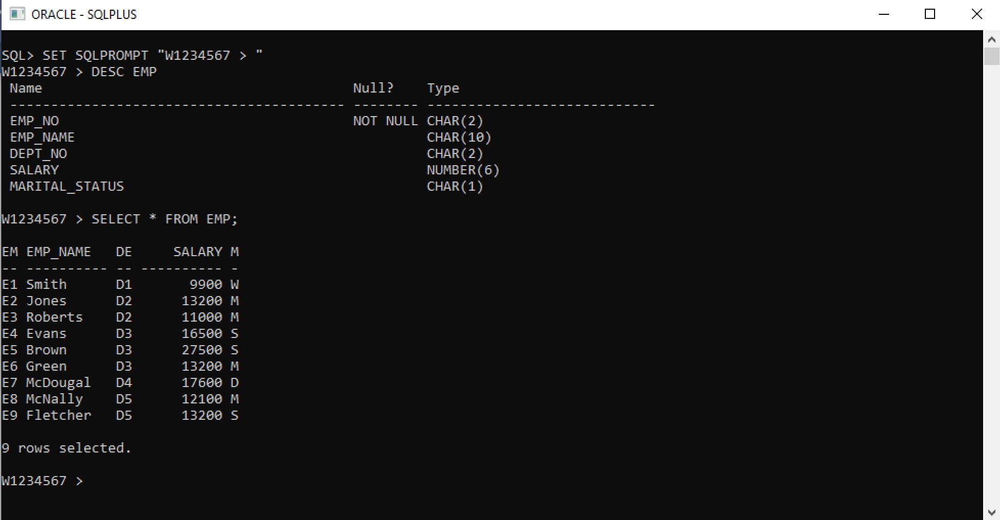

**Assignment Questions**

**Part 1 (35 marks)**

This part is based on the BLS scenario as described in the Appendix.

1. *Using entity-relationship (ER) OR enhanced entity-relationship (EER) modelling, produce a conceptual design for the database to support the BLS required by BCC.*

(10 marks)

**Answer Part 1 A: Insert your ER or EER Diagram Below**

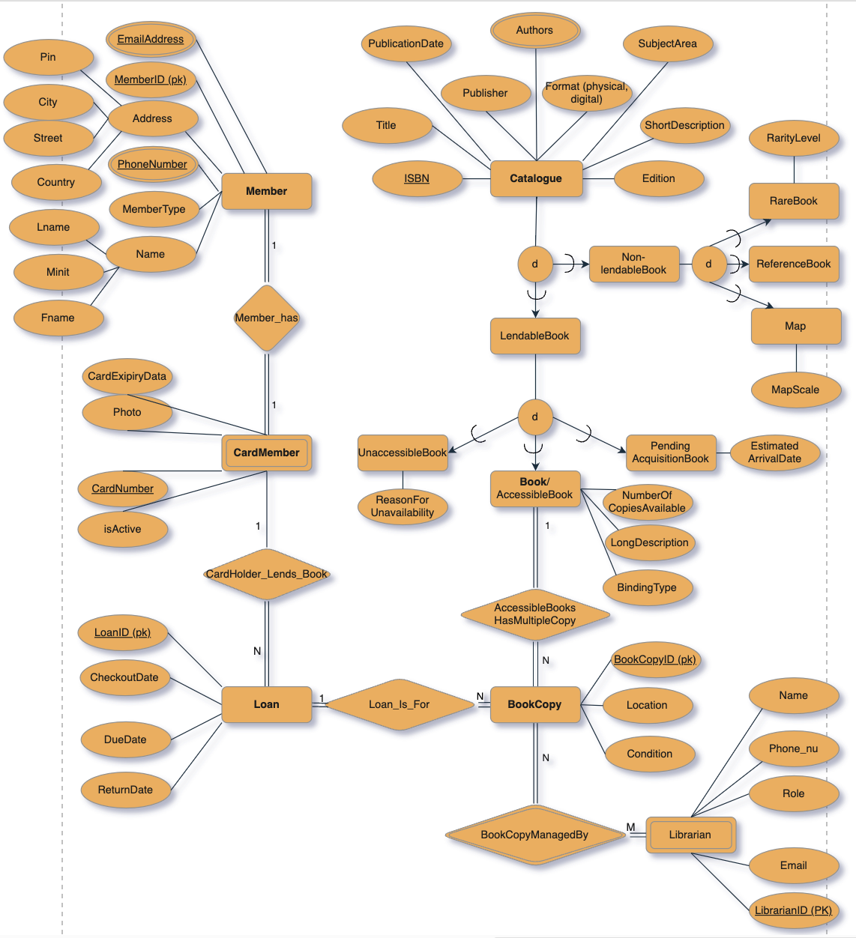

1. *Convert the ER / EER diagram from Part 1(A) to produce a logical relational schema using ER / EER to relational mapping****.***

(15 marks)

**Answer Part 1 B: Provide your Logical Relational Design/Schema Below**

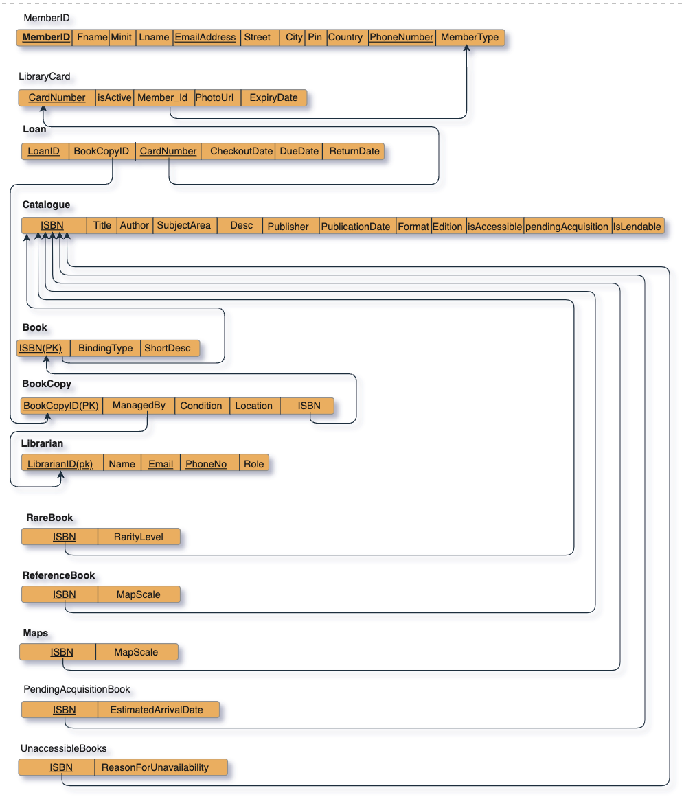

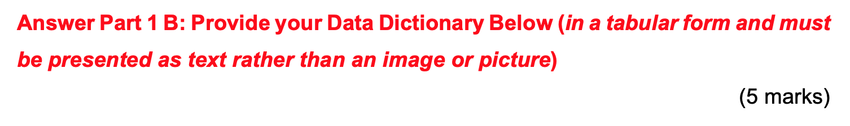

|  |  |  |  |  |
| --- | --- | --- | --- | --- |
| **Table Name** | **Column Name** | **Data type** | **Constraints** | **Descriptions** |
| member | member_id | NUMBER(4) | PRIMARY KEY | The member id of the user |
| fname | VARCHAR2(50) |  | the first name of the user |
| minit | VARCHAR2(50) |  | the middle name of the user |
| lname | VARCHAR2(50) |  | the last name of the user |
| street | VARCHAR2(50) |  | the street address of the user |
| city | VARCHAR2(50) |  | the city address of the user |
| pin | VARCHAR2(6) |  | the pin address of the user |
| country | VARCHAR2(65) |  | the country name of the user |
| phone_number | NUMBER(12) |  | the phone number of the user |
| email_address | VARCHAR2(200) |  | the email address of the user |
| member_type | VARCHAR2(10) | CONSTRAINT member_type_check CHECK (member_type IN ('standard', 'councillor') | the type of the user , whether normal user ot=r councilor |
| card | card_number | NUMBER(4) | PRIMARY KEY, NOT NULL | the card number of the user |
| is_active | VARCHAR(5) | CHECK (is_active IN ('true', 'false')) | checking whether the user is active or not |
| member_id | NUMBER(4) | FOREIGN KEY,NOT NULL | the member id of the user |
| photo_url | VARCHAR2(200) |  | the url where the user photo is stored |
| expiry_date | VARCHAR2(100) | NOT NULL | the expiry date of the library card |
| catalogue | isbn NUMBER(13) |  | PRIMARY KEY, NOT NULL | the isbn number of the book |
| title | VARCHAR2(100) | NOT NULL | the title of a book |
| authors | VARCHAR2(200) | NOT NULL | the authors of the book |
| publication_date | DATE | NOT NULL | publication_date of the book |
| edition | VARCHAR2(50) |  | edition of the book |
| format | VARCHAR2(20) | CHECK (format IN ('physical', 'digital')) | format of the book |
| subject_area | VARCHAR2(100) | NOT NULL | subject_area of the book |
| description | VARCHAR2(100) | NOT NULL | description of the book |
| is_lendable | VARCHAR(5) | NOT NULL,CHECK (is_lendable IN ('true', 'false')) | Whether it is rentable or not |
| is_accessible | VARCHAR(5) | NOT NULL, CHECK (is_accessible IN ('true', 'false')) | check to see if the book is accessible |
| pending_acquisition | VARCHAR(5) | NOT NULL, CHECK (pending_acquisition IN ('true', 'false')) | check to see if the book is yet to arrive |
| book | isbn | NUMBER(13) | PRIMARY KEY, NOT NULL | The isbn of the book |
| binding_type | VARCHAR2(9) | NOT NULL, CHECK (binding_type IN ('hardcover', 'softcover')) | The type of binding of the book |
| short_desc | VARCHAR2(200) |  | the description of the book |
| librarian | librarian_id | NUMBER(4) | PRIMARY KEY, NOT NULL | The librarian identification number |
| name | VARCHAR2(100) | NOT NULL | the name of the librarian |
| email | VARCHAR2(50) | NOT NULL | the email address of the librarian |
| phone_number | NUMBER(12) | NOT NULL | the phoen number of the librarian |
| role | VARCHAR2(27) | NOT NULL, CHECK (role IN ('senior_librarian', 'associate_librarian', 'reference_librarian', 'check_out_and_returns_staff', 'library_assistant')) | the designation or task of the librarian |
| book_copy | book_copy_id |  | PRIMARY KEY, NOT NULL | the identification number of the book copy |
| isbn | NUMBER(13) | FOREIGN KEY, NOT NULL | the isbn number of the book copy |
| condition | VARCHAR2(50) | NOT NULL | the condition of the book |
| location | VARCHAR2(20) | NOT NULL, CHECK (location IN ('Shelf A', 'Shelf B', 'Shelf C', 'Shelf D', 'Reference', 'Rare Books')) | the location of the book in the library |
| managed_by | NUMBER(4) | FOREIGN KEY | the librarian id by whom the book is managed |
| loan | loan_id |  | PRIMARY KEY, NOT NULL | the loan id of the book |
| card_number | INT | FOREIGN KEY, NOT NULL | the card number who borrowed the book |
| book_copy_id | INT | FOREIGN KEY, NOT NULL | the book copy number of the book borrowed |
| checkout_date | DATE | NOT NULL | the date of the book checkout |
| due_date | DATE | NOT NULL | the due date for the borrowing |
| return_date | DATE | NOT NULL | the return date of the book |
| rare_book | isbn | NUMBER(13) | PRIMARY KEY, FOREIGN KEY | the isbn number of the book |
| rarity_level | VARCHAR2(7) |  | the rarity level of the book |
| maps | isbn | NUMBER(13) | PRIMARY KEY, FOREIGN KEY | the isbn number if the book |
| scale | VARCHAR2(10) |  | the scale |
| reference_book | isbn | NUMBER(13) | PRIMARY KEY, FOREIGN KEY | the isbn number if the book |
| rarity_level | VARCHAR2(7) |  |  |
| pending_acquisition_book | isbn NUMBER(13) | NUMBER(13) | PRIMARY KEY, FOREIGN KEY | the isbn number if the book |
| estimated_arrival_date | DATE |  | The arrival date |
| unaccessible_books | isbn | NUMBER(13) | PRIMARY KEY, FOREIGN KEY | the isbn number if the book |
| reason_for_unavailability | VARCHAR2(50) |  | the reason for unavailability |

*(C) Based on your logical design from Part 1 (B) and the information available in the scenario, produce an SQL script file using Oracle 11g/12c/higher.*

(10 marks)

**Answer Part 1 C: Provide SQL DDL Script file contents (i.e., the SQL code for creating / altering your Tables / Constraints etc)**

|  |
| --- |
| -- Create the sequence for the member_id column in the member table for automatic update of member id CREATE SEQUENCE member_id_seq;  -- Create the member table CREATE TABLE member (  member_id NUMBER(4) DEFAULT member_id_seq.nextval NOT NULL,  fname VARCHAR2(50) NOT NULL,  minit VARCHAR2(50),  lname VARCHAR2(50) NOT NULL,  street VARCHAR2(50) NOT NULL,  city VARCHAR2(50) NOT NULL,  pin VARCHAR2(6) NOT NULL,  country VARCHAR2(65) NOT NULL,  phone_number NUMBER(12) NOT NULL,  email_address VARCHAR2(200) NOT NULL,  member_type VARCHAR2(10) NOT NULL,  PRIMARY KEY (member_id),  CONSTRAINT member_type_check CHECK (member_type IN ('standard', 'councillor')) );  -- Create the sequence for the card_id column in the card table CREATE SEQUENCE card_id_seq;  -- Create the card table CREATE TABLE card (  card_number NUMBER(4) DEFAULT card_id_seq.nextval NOT NULL,  is_active VARCHAR(5),  member_id NUMBER(4) NOT NULL,  photo_url VARCHAR2(200) NOT NULL,  expiry_date VARCHAR2(100) NOT NULL, -- to-do add today's date plus 4 years  CONSTRAINT pk_card_number PRIMARY KEY (card_number),  CONSTRAINT fk_member_id_card_number FOREIGN KEY (member_id) REFERENCES member(member_id),  CONSTRAINT is_active_check CHECK (is_active IN ('true', 'false')) );  -- Create the catalogue table CREATE TABLE catalogue (  isbn NUMBER(13) NOT NULL,  title VARCHAR2(100) NOT NULL,  authors VARCHAR2(200) NOT NULL,  publisher VARCHAR2(255) NOT NULL,  publication_date DATE NOT NULL,  edition VARCHAR2(50),  format VARCHAR2(20),  subject_area VARCHAR2(100) NOT NULL,  description VARCHAR2(100) NOT NULL,  is_lendable VARCHAR(5) NOT NULL,  is_accessible VARCHAR(5) NOT NULL,  pending_acquisition VARCHAR(5) NOT NULL,  CONSTRAINT pk_isbn PRIMARY KEY (isbn),  CONSTRAINT format_check CHECK (format IN ('physical', 'digital')),  CONSTRAINT is_lendable_check CHECK (is_lendable IN ('true', 'false')),  CONSTRAINT is_accessible_check CHECK (is_accessible IN ('true', 'false')),  CONSTRAINT pending_acquisition_check CHECK (pending_acquisition IN ('true', 'false')) );  -- Create the book table that can be lent to cardholders CREATE TABLE book (  isbn NUMBER(13) NOT NULL,  binding_type VARCHAR2(9) NOT NULL,  short_desc VARCHAR2(200),  CONSTRAINT binding_type_check CHECK (binding_type IN ('hardcover', 'softcover')),  CONSTRAINT pk_isbn_book PRIMARY KEY (isbn) );  -- Create the sequence for the librarian_id column in the librarian table CREATE SEQUENCE librarian_id_seq;  -- Create the librarian table CREATE TABLE librarian (  librarian_id NUMBER(4) DEFAULT librarian_id_seq.nextval NOT NULL,  name VARCHAR2(100) NOT NULL,  email VARCHAR2(50) NOT NULL,  phone_number NUMBER(12) NOT NULL,  role VARCHAR2(27) NOT NULL,  CONSTRAINT pk_librarian_id PRIMARY KEY (librarian_id),  CONSTRAINT role_check CHECK (role IN ('senior_librarian', 'associate_librarian', 'reference_librarian', 'check_out_and_returns_staff', 'library_assistant')) );  -- Create the sequence for the book_copy_id column in the book_copy table CREATE SEQUENCE book_copy_id_seq;  -- Create the book_copy table CREATE TABLE book_copy (  book_copy_id INT DEFAULT book_copy_id_seq.nextval NOT NULL,  isbn NUMBER(13) NOT NULL,  condition VARCHAR2(50) NOT NULL,  location VARCHAR2(20) NOT NULL,  managed_by NUMBER(4),  CONSTRAINT location_check CHECK (location IN ('Shelf A', 'Shelf B', 'Shelf C', 'Shelf D', 'Reference', 'Rare Books')),  CONSTRAINT pk_book_copy_id PRIMARY KEY (book_copy_id),  CONSTRAINT fk_isbn_book_copy FOREIGN KEY (isbn) REFERENCES book(isbn),  CONSTRAINT fk_managed_by_book_copy FOREIGN KEY (managed_by) REFERENCES librarian(librarian_id) );  -- Create the sequence for the loan_id column in the loan table CREATE SEQUENCE loan_id_seq;  -- Create the loan table CREATE TABLE loan (  loan_id INT DEFAULT loan_id_seq.nextval NOT NULL,  card_number INT NOT NULL,  book_copy_id INT NOT NULL,  checkout_date DATE NOT NULL,  due_date DATE NOT NULL,  return_date DATE NULL,  CONSTRAINT pk_loan_id PRIMARY KEY (loan_id),  CONSTRAINT fk_card_number_loan FOREIGN KEY (card_number) REFERENCES card(card_number),  CONSTRAINT fk_book_copy_id_loan FOREIGN KEY (book_copy_id) REFERENCES book_copy(book_copy_id) );  -- Create the rare_book table CREATE TABLE rare_book (  isbn NUMBER(13),  rarity_level VARCHAR2(7),  CONSTRAINT pk_isbn_rare_book PRIMARY KEY (isbn),  CONSTRAINT fk_isbn_rare_book FOREIGN KEY (isbn) REFERENCES catalogue(isbn) );  -- Create the maps table CREATE TABLE maps (  isbn NUMBER(13),  scale VARCHAR2(10),  CONSTRAINT pk_isbn_maps PRIMARY KEY (isbn),  CONSTRAINT fk_isbn_maps FOREIGN KEY (isbn) REFERENCES catalogue(isbn) );  -- Create the reference_book table CREATE TABLE reference_book (  isbn NUMBER(13),  rarity_level VARCHAR2(7),  CONSTRAINT pk_isbn_reference_book PRIMARY KEY (isbn),  CONSTRAINT fk_isbn_reference_book FOREIGN KEY (isbn) REFERENCES catalogue(isbn) );  -- Create the pending_acquisition_book table CREATE TABLE pending_acquisition_book (  isbn NUMBER(13),  estimated_arrival_date DATE,  CONSTRAINT pk_isbn_pending_acquisition_book PRIMARY KEY (isbn),  CONSTRAINT fk_isbn_pending_acquisition_book FOREIGN KEY (isbn) REFERENCES catalogue(isbn) );  -- Create the unaccessible_books table CREATE TABLE unaccessible_books (  isbn NUMBER(13),  reason_for_unavailability VARCHAR2(50),  CONSTRAINT pk_isbn_unaccessible_books PRIMARY KEY (isbn),  CONSTRAINT fk_isbn_unaccessible_books FOREIGN KEY (isbn) REFERENCES catalogue(isbn) ); |

**Answer Part 1 C: SQL DDL Output (e.g., SPOOL file contents or output you got when you executed your above SQL Table Creation code, this should show the SQL code as well as its output). Make sure the output is a screenshot / image or picture and NOT a simple TEXT as it may increase your Turn-it-in similarity score.**

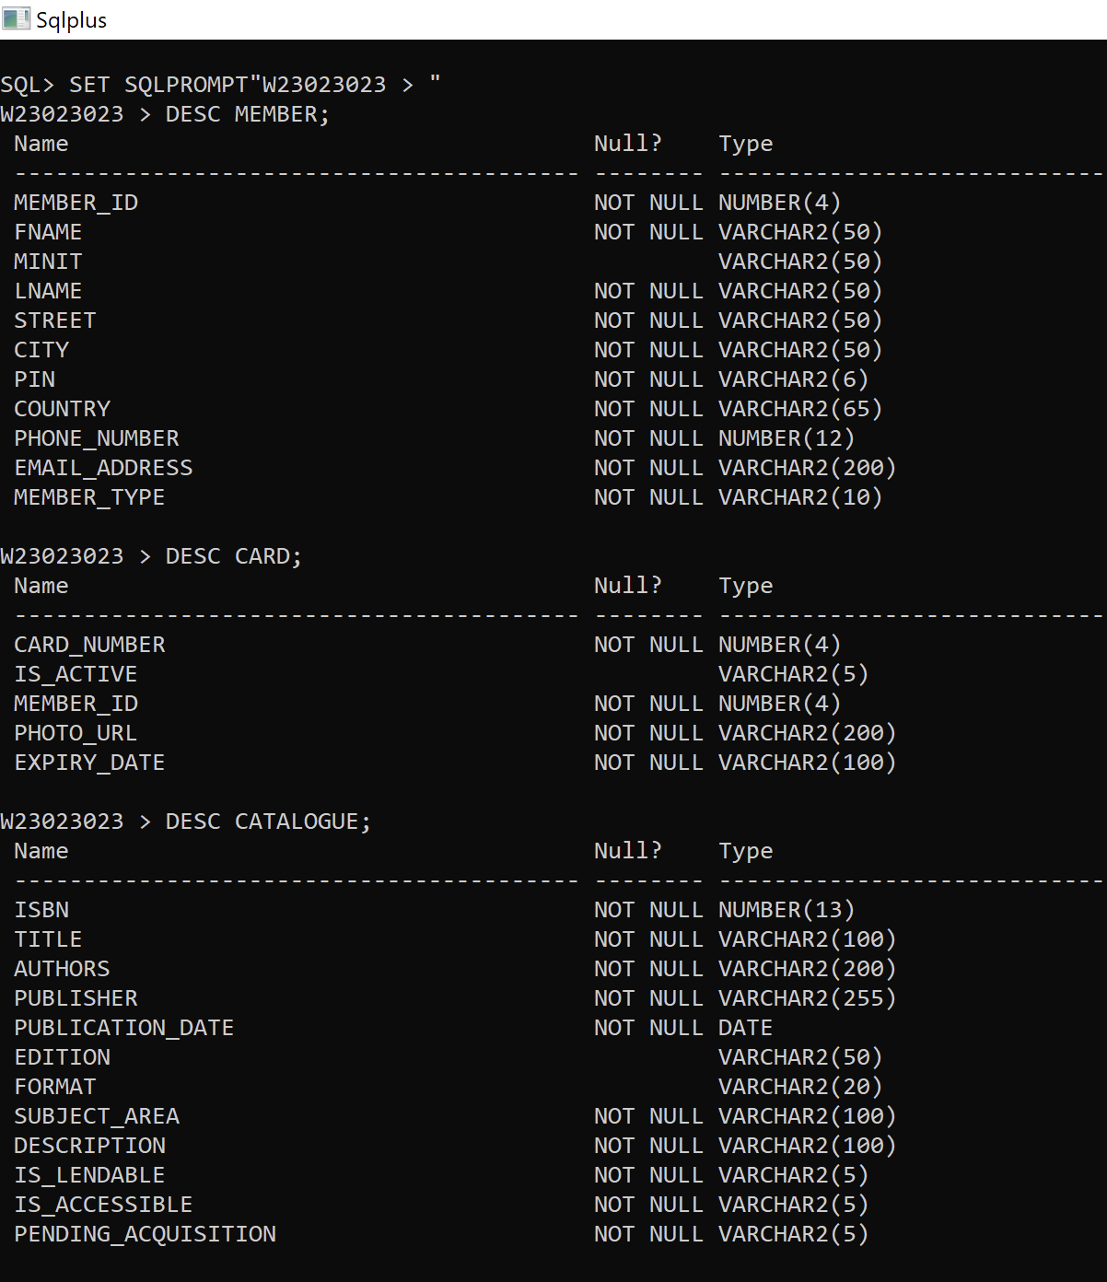

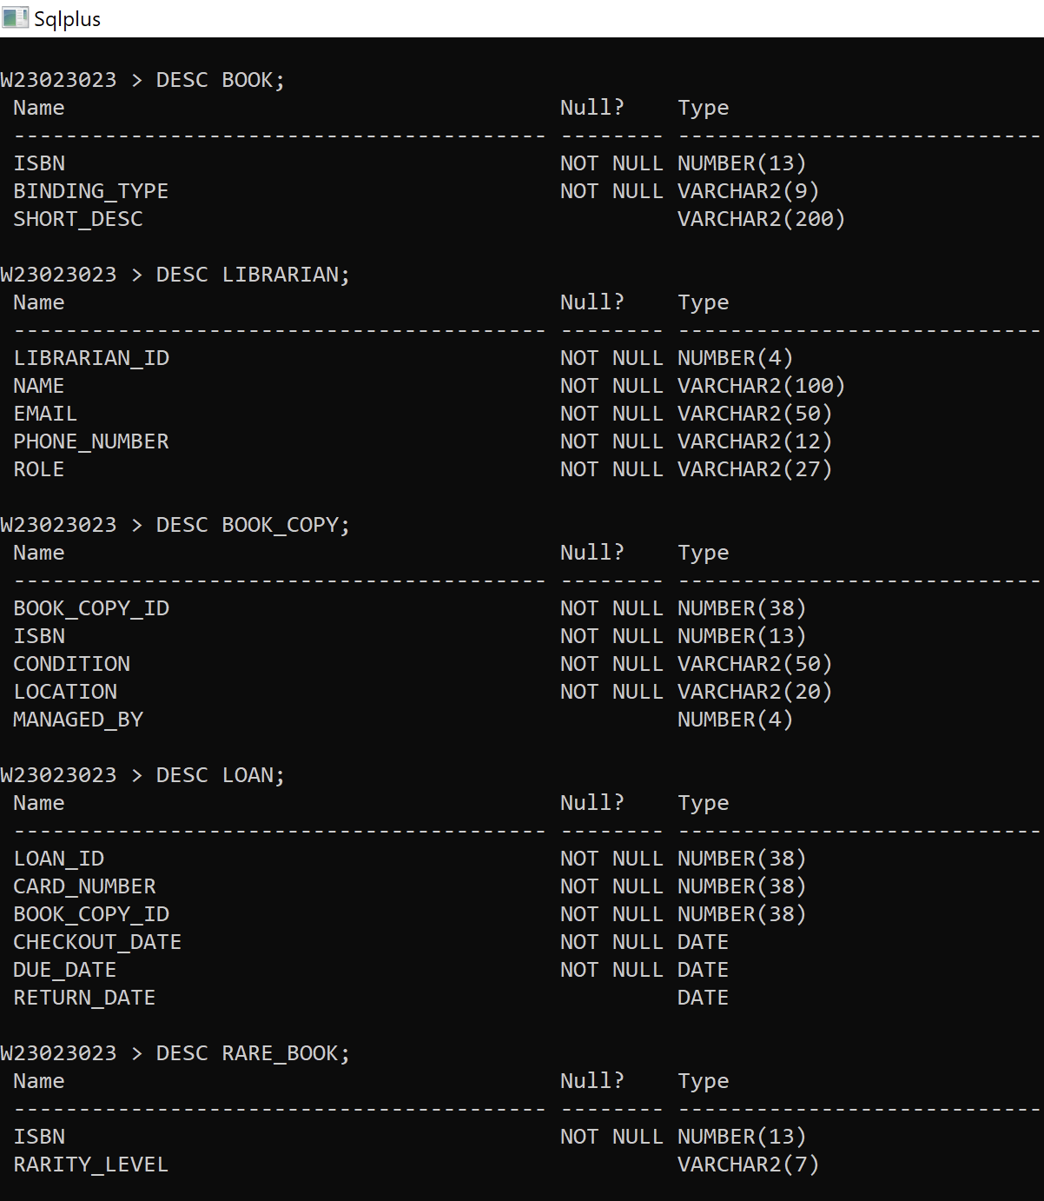

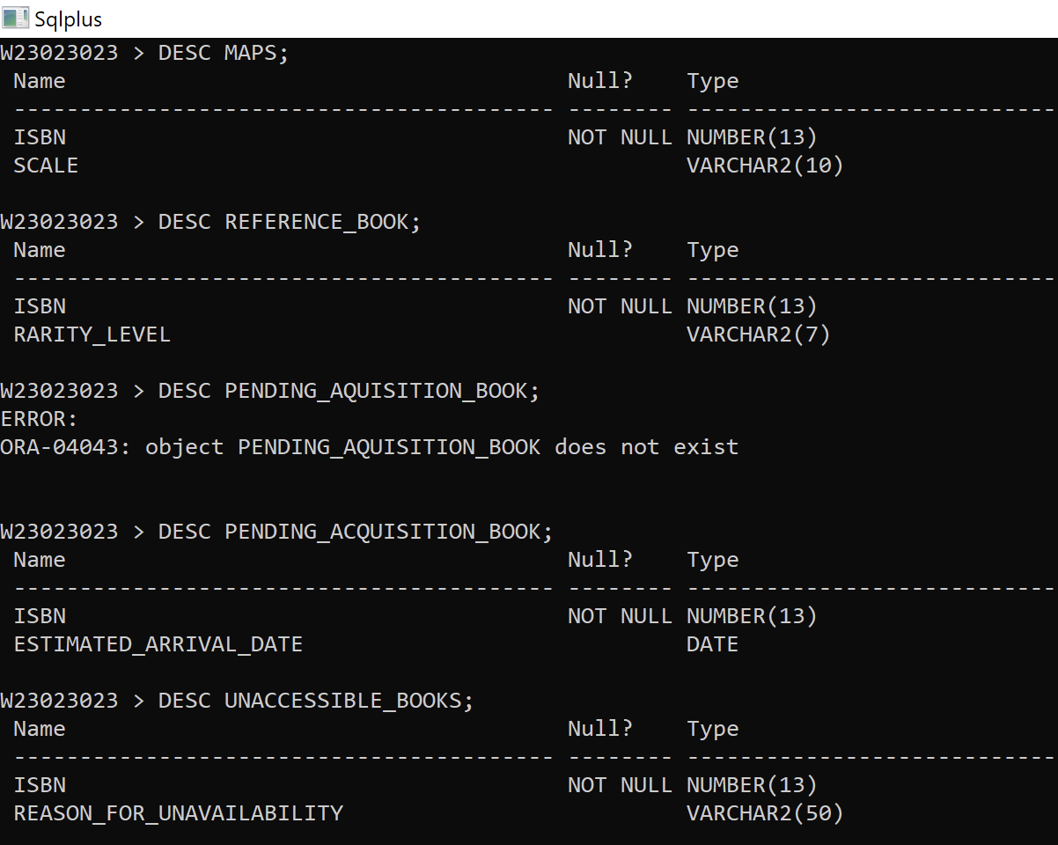

**Part 2 (20 marks)**

This part is based on your answer / solution to Part 1, i.e., design and implementation of the database for the BLS scenario.

*(A) Populate the database with some sample data (e.g., you should generate your own dummy data and load it into the BLS database, consider 5 to 10 rows for each table and enough data to see meaningful output for the queries below)*.

(10 marks)

**Answer Part 2 A: Provide SQL code below for populating the above relational database.**

|  |
| --- |
| **-- Inserting dummy data into the member table**  **INSERT INTO member (member_id, fname, minit, lname, street, city, pin, country, phone_number, email_address, member_type)VALUES (1, 'John', 'D', 'Doe', '123 Main St', 'Cityville', '12345', 'UK', 5551234567, 'john.doe@northumbria.ac.in', 'standard');**  **INSERT INTO member (member_id, fname, minit, lname, street, city, pin, country, phone_number, email_address, member_type)VALUES (2, 'Jane', 'M', 'Smith', '456 Oak Ave', 'Townsville', '67890', 'UK', 5559876543, 'jane.smith@northumbria.ac.in', 'standard');**  **INSERT INTO member (member_id, fname, minit, lname, street, city, pin, country, phone_number, email_address, member_type)VALUES (3, 'Bob', 'A', 'Johnson', '789 Pine Rd', 'Villageton', '54321', 'UK', 5551112233, 'bob.johnson@northumbria.ac.in', 'standard');**  **INSERT INTO member (member_id, fname, minit, lname, street, city, pin, country, phone_number, email_address, member_type)VALUES (4, 'Alice', 'B', 'Williams', '101 Maple St', 'Cityburg', '98765', 'UK', 5554445678, 'alice.williams@northumbria.ac.in', 'standard');**  **INSERT INTO member (member_id, fname, minit, lname, street, city, pin, country, phone_number, email_address, member_type)VALUES (5, 'Charlie', 'C', 'Brown', '202 Elm Ave', 'Villagetown', '13579', 'UK', 5558765432, 'charlie.brown@northumbria.ac.in', 'standard');**  **INSERT INTO member (member_id, fname, minit, lname, street, city, pin, country, phone_number, email_address, member_type)VALUES (6, 'Eva', 'K', 'Miller', '303 Cedar St', 'Villageville', '24680', 'UK', 5553339999, 'eva.miller@northumbria.ac.in', 'councillor');**  **INSERT INTO member (member_id, fname, minit, lname, street, city, pin, country, phone_number, email_address, member_type)VALUES (7, 'David', 'L', 'Taylor', '404 Birch Rd', 'Townburg', '86420', 'UK', 5557771111, 'david.taylor@northumbria.ac.in', 'councillor');**  **INSERT INTO member (member_id, fname, minit, lname, street, city, pin, country, phone_number, email_address, member_type)VALUES (8, 'Sophie', 'E', 'Anderson', '505 Pine Ave', 'Villagesburg', '97531', 'UK', 5552228888, 'sophie.anderson@northumbria.ac.in', 'councillor');**  **INSERT INTO member (member_id, fname, minit, lname, street, city, pin, country, phone_number, email_address, member_type)VALUES (9, 'Frank', 'F', 'Clark', '606 Elm Rd', 'Citytown', '75309', 'UK', 5556662222, 'frank.clark@northumbria.ac.in', 'standard');**  **INSERT INTO member (member_id, fname, minit, lname, street, city, pin, country, phone_number, email_address, member_type)VALUES (10, 'Olivia', 'G', 'Hill', '707 Oak Ave', 'Villageland', '13579', 'UK', 5559993333, 'olivia.hill@northumbria.ac.in', 'standard');**  **INSERT INTO member (member_id, fname, minit, lname, street, city, pin, country, phone_number, email_address, member_type)VALUES (11, 'Gabriel', 'H', 'Cooper', '808 Maple St', 'Villagetown', '24680', 'UK', 5551110000, 'gabriel.cooper@northumbria.ac.in', 'standard');**  **INSERT INTO member (member_id, fname, minit, lname, street, city, pin, country, phone_number, email_address, member_type)VALUES (12, 'Emma', 'I', 'Baker', '909 Cedar Ave', 'Cityville', '97531', 'UK', 5558884444, 'emma.baker@northumbria.ac.in', 'standard');**  **INSERT INTO member (member_id, fname, minit, lname, street, city, pin, country, phone_number, email_address, member_type)VALUES (13, 'Harrison', 'J', 'Martin', '101 Birch Rd', 'Villagesburg', '75309', 'UK', 5552227777, 'harrison.martin@northumbria.ac.in', 'standard');**  **INSERT INTO member (member_id, fname, minit, lname, street, city, pin, country, phone_number, email_address, member_type)VALUES (14, 'Isabella', 'K', 'Ward', '202 Pine Ave', 'Townburg', '86420', 'UK', 5555551234, 'isabella.ward@northumbria.ac.in', 'standard');**  **INSERT INTO member (member_id, fname, minit, lname, street, city, pin, country, phone_number, email_address, member_type)VALUES (15, 'Jackson', 'L', 'Fisher', '303 Elm Rd', 'Villageville', '43210', 'UK', 5553336666, 'jackson.fisher@northumbria.ac.in', 'standard');**  **INSERT INTO member (member_id, fname, minit, lname, street, city, pin, country, phone_number, email_address, member_type)VALUES (16, 'Zoe', 'M', 'Roberts', '404 Oak Ave', 'Citytown', '98765', 'UK', 5557770000, 'zoe.roberts@northumbria.ac.in', 'standard');**  **INSERT INTO member (member_id, fname, minit, lname, street, city, pin, country, phone_number, email_address, member_type)VALUES (17, 'Mason', 'N', 'Turner', '505 Pine Rd', 'Villageton', '54321', 'UK', 5551114444, 'mason.turner@northumbria.ac.in', 'standard');**  **INSERT INTO member (member_id, fname, minit, lname, street, city, pin, country, phone_number, email_address, member_type)VALUES (18, 'Ava', 'O', 'Harrison', '606 Cedar Ave', 'Cityville', '12345', 'UK', 5556669999, 'ava.harrison@northumbria.ac.in', 'standard');**  **INSERT INTO member (member_id, fname, minit, lname, street, city, pin, country, phone_number, email_address, member_type)VALUES (19, 'Ethan', 'P', 'Ferguson', '707 Elm Rd', 'Villageville', '86420', 'UK', 5552223333, 'ethan.ferguson@northumbria.ac.in', 'standard');**  **INSERT INTO member (member_id, fname, minit, lname, street, city, pin, country, phone_number, email_address, member_type)VALUES (20, 'Nora', 'Q', 'Owens', '808 Maple Ave', 'Townburg', '24680', 'UK', 5558887777, 'nora.owens@northumbria.ac.in', 'standard');**  **-- Inserting dummy data into the card table, referencing member table data**  **INSERT INTO card (card_number, is_active, member_id, photo_url, expiry_date)VALUES (1, 'true', 1, 'photo_url_1.jpg', '2023-12-01');**  **INSERT INTO card (card_number, is_active, member_id, photo_url, expiry_date)VALUES (2, 'true', 2, 'photo_url_2.jpg', '2023-12-02');**  **INSERT INTO card (card_number, is_active, member_id, photo_url, expiry_date)VALUES (3, 'true', 3, 'photo_url_3.jpg', '2023-12-03');**  **INSERT INTO card (card_number, is_active, member_id, photo_url, expiry_date)VALUES (4, 'true', 4, 'photo_url_4.jpg', '2023-12-04');**  **INSERT INTO card (card_number, is_active, member_id, photo_url, expiry_date)VALUES (5, 'true', 5, 'photo_url_5.jpg', '2023-12-05');**  **INSERT INTO card (card_number, is_active, member_id, photo_url, expiry_date)VALUES (6, 'false', 6, 'photo_url_6.jpg', '2023-12-06');**  **INSERT INTO card (card_number, is_active, member_id, photo_url, expiry_date)VALUES (7, 'false', 7, 'photo_url_7.jpg', '2023-12-07');**  **INSERT INTO card (card_number, is_active, member_id, photo_url, expiry_date)VALUES (8, 'false', 8, 'photo_url_8.jpg', '2023-12-08');**  **INSERT INTO card (card_number, is_active, member_id, photo_url, expiry_date)VALUES (9, 'false', 9, 'photo_url_9.jpg', '2023-12-09');**  **INSERT INTO card (card_number, is_active, member_id, photo_url, expiry_date)VALUES (10, 'false', 10, 'photo_url_10.jpg', '2023-12-10');**  **INSERT INTO card (card_number, is_active, member_id, photo_url, expiry_date)VALUES (11, 'true', 11, 'photo_url_11.jpg', '2023-12-11');**  **INSERT INTO card (card_number, is_active, member_id, photo_url, expiry_date)VALUES (12, 'true', 12, 'photo_url_12.jpg', '2023-12-12');**  **INSERT INTO card (card_number, is_active, member_id, photo_url, expiry_date)VALUES (13, 'true', 13, 'photo_url_13.jpg', '2023-12-13');**  **INSERT INTO card (card_number, is_active, member_id, photo_url, expiry_date)VALUES (14, 'true', 14, 'photo_url_14.jpg', '2023-12-14');**  **INSERT INTO card (card_number, is_active, member_id, photo_url, expiry_date)VALUES (15, 'true', 15, 'photo_url_15.jpg', '2023-12-15');**  **INSERT INTO card (card_number, is_active, member_id, photo_url, expiry_date)VALUES (16, 'false', 16, 'photo_url_16.jpg', '2023-12-16');**  **INSERT INTO card (card_number, is_active, member_id, photo_url, expiry_date)VALUES (17, 'false', 17, 'photo_url_17.jpg', '2023-12-17');**  **INSERT INTO card (card_number, is_active, member_id, photo_url, expiry_date)VALUES (18, 'false', 18, 'photo_url_18.jpg', '2023-12-18');**  **INSERT INTO card (card_number, is_active, member_id, photo_url, expiry_date)VALUES (19, 'false', 19, 'photo_url_19.jpg', '2023-12-19');**  **INSERT INTO card (card_number, is_active, member_id, photo_url, expiry_date)VALUES (20, 'false', 20, 'photo_url_20.jpg', '2023-12-20');**  **-- Inserting data into the catalogue table from rare_book data**  **INSERT INTO catalogue (isbn, title, authors, publisher, publication_date, edition, format, subject_area, description, is_lendable, is_accessible, pending_acquisition)VALUES (5678901234567, 'Antique Manuscripts: A Collector''s Guide', 'History Experts', 'Collector''s Press', TO_DATE('2022-09-15', 'YYYY-MM-DD'), '1st Edition', 'physical', 'History', 'Exploring rare manuscripts from different eras.', 'false', 'true', 'false');**  **INSERT INTO catalogue (isbn, title, authors, publisher, publication_date, edition, format, subject_area, description, is_lendable, is_accessible, pending_acquisition)VALUES (6789012345678, 'Lost Civilizations: Unearthed Secrets', 'Archaeology Scholars', 'Discovery Books', TO_DATE('2022-12-08', 'YYYY-MM-DD'), '2nd Edition', 'physical', 'Archaeology', 'Revealing the mysteries of lost civilizations.', 'false', 'true', 'false');**  **-- Inserting data into the catalogue table from maps data**  **INSERT INTO catalogue (isbn, title, authors, publisher, publication_date, edition, format, subject_area, description, is_lendable, is_accessible, pending_acquisition)VALUES (3456789012345, 'City Explorer: Downtown Metropolis', 'Cartography Experts', 'MapQuest Publications', TO_DATE('2022-08-10', 'YYYY-MM-DD'), '1st Edition', 'physical', 'Geography', 'Detailed map for exploring downtown areas.', 'false', 'true', 'false');**  **INSERT INTO catalogue (isbn, title, authors, publisher, publication_date, edition, format, subject_area, description, is_lendable, is_accessible, pending_acquisition)VALUES (4567890123456, 'Outdoor Adventures: Mountain Trails', 'Geography Enthusiasts', 'Adventure Maps Co.', TO_DATE('2022-11-25', 'YYYY-MM-DD'), '2nd Edition', 'physical', 'Geography', 'Explore mountain trails with this topographic map.', 'false', 'true', 'false');**  **-- Inserting data into the catalogue table from reference_book data**  **INSERT INTO catalogue (isbn, title, authors, publisher, publication_date, edition, format, subject_area, description, is_lendable, is_accessible, pending_acquisition)VALUES (1234567890123, 'The Enigma of Ancient Artifacts', 'Archaeology Experts', 'Archaeological Society Press', TO_DATE('2022-07-20', 'YYYY-MM-DD'), '1st Edition', 'physical', 'Archaeology', 'Decoding mysteries of ancient artifacts.', 'false', 'true', 'false');**  **INSERT INTO catalogue (isbn, title, authors, publisher, publication_date, edition, format, subject_area, description, is_lendable, is_accessible, pending_acquisition)VALUES (2345678901234, 'Essentials of Computer Science', 'Computer Science Professors', 'TechKnowledge Publishers', TO_DATE('2022-10-05', 'YYYY-MM-DD'), '3rd Edition', 'digital', 'Computer Science', 'A comprehensive guide to computer science basics.', 'false', 'true', 'false');**  **-- Inserting data into the catalogue table from pending_acquisition_book data**  **INSERT INTO catalogue (isbn, title, authors, publisher, publication_date, edition, format, subject_area, description, is_lendable, is_accessible, pending_acquisition)VALUES (9876543210987, 'Discovering the Cosmos', 'Astronomy Experts', 'Stellar Publishing', TO_DATE('2023-01-15', 'YYYY-MM-DD'), '1st Edition', 'physical', 'Astronomy', 'Exploring the wonders of the universe.', 'true', 'true', 'false');**  **INSERT INTO catalogue (isbn, title, authors, publisher, publication_date, edition, format, subject_area, description, is_lendable, is_accessible, pending_acquisition)VALUES (8765432109876, 'World History Unveiled', 'History Scholars', 'Historical Press', TO_DATE('2023-03-10', 'YYYY-MM-DD'), '2nd Edition', 'physical', 'History', 'Unraveling the secrets of global history.', 'true', 'true', 'false');**  **-- Inserting data into the catalogue table from unaccessible_books data**  **INSERT INTO catalogue (isbn, title, authors, publisher, publication_date, edition, format, subject_area, description, is_lendable, is_accessible, pending_acquisition)VALUES (1234567890987, 'The Art of Repair', 'John Fixer', 'Restoration Publishing', TO_DATE('2022-05-15', 'YYYY-MM-DD'), '1st Edition', 'physical', 'Craftsmanship', 'A guide to repairing damaged books.', 'true', 'false', 'false');**  **INSERT INTO catalogue (isbn, title, authors, publisher, publication_date, edition, format, subject_area, description, is_lendable, is_accessible, pending_acquisition)VALUES (2345678901986, 'Cover Stories', 'Alice Binder', 'Book Arts Press', TO_DATE('2021-09-20', 'YYYY-MM-DD'), '2nd Edition', 'physical', 'Book Design', 'An exploration of book cover designs.', 'true', 'false', 'false');**  **-- Inserting dummy data into the rare_book table**  **INSERT INTO rare_book (isbn, rarity_level)VALUES (5678901234567, 'Rare');**  **INSERT INTO rare_book (isbn, rarity_level)VALUES (6789012345678, 'Common');**  **-- Inserting dummy data into the maps table**  **INSERT INTO maps (isbn, scale)VALUES (3456789012345, '1:10000');**  **INSERT INTO maps (isbn, scale)VALUES (4567890123456, '1:5000');**  **-- Inserting dummy data into the reference_book table**  **INSERT INTO reference_book (isbn, rarity_level)VALUES (1234567890123, 'Rare');**  **INSERT INTO reference_book (isbn, rarity_level)VALUES (2345678901234, 'Common');**  **-- Inserting dummy data into the pending_acquisition_book table**  **INSERT INTO pending_acquisition_book (isbn, estimated_arrival_date)VALUES (9876543210987, TO_DATE('2024-07-20', 'YYYY-MM-DD'));**  **INSERT INTO pending_acquisition_book (isbn, estimated_arrival_date)VALUES (8765432109876, TO_DATE('2025-07-20', 'YYYY-MM-DD'));**  **-- Inserting dummy data into the unaccessible_books table**  **INSERT INTO unaccessible_books (isbn, reason_for_unavailability)**  **VALUES (1234567890987, 'Damaged pages restoration ongoing');**  **INSERT INTO unaccessible_books (isbn, reason_for_unavailability)**  **VALUES (2345678901986, 'Missing cover restoration ongoing');**  **-- Inserting rows into the catalogue table for the books**  **INSERT INTO catalogue (isbn, title, authors, publisher, publication_date, edition, format, subject_area, description, is_lendable, is_accessible, pending_acquisition)**  **VALUES (9876543111111, 'Introduction to Physics', 'Akhtar Ali', 'Science Publishing', TO_DATE('2022-08-01', 'YYYY-MM-DD'), '1st Edition', 'physical', 'Physics', 'Comprehensive guide to basic physics concepts.', 'true', 'false', 'false');**  **INSERT INTO catalogue (isbn, title, authors, publisher, publication_date, edition, format, subject_area, description, is_lendable, is_accessible, pending_acquisition)**  **VALUES (9876543222222, 'The Art of Cooking', 'Mohammad Rizvi', 'Cuisine Books Co.', TO_DATE('2022-10-15', 'YYYY-MM-DD'), '2nd Edition', 'physical', 'Culinary Arts', 'Exploring the art and science of cooking.', 'true', 'false', 'false');**  **INSERT INTO catalogue (isbn, title, authors, publisher, publication_date, edition, format, subject_area, description, is_lendable, is_accessible, pending_acquisition)**  **VALUES (9876543333333, 'Programming in Python', 'Muhammad Muzammal', 'TechKnowledge Publishers', TO_DATE('2022-12-20', 'YYYY-MM-DD'), '3rd Edition', 'digital', 'Computer Science', 'A practical guide to Python programming.', 'true', 'false', 'false');**  **INSERT INTO catalogue (isbn, title, authors, publisher, publication_date, edition, format, subject_area, description, is_lendable, is_accessible, pending_acquisition)**  **VALUES (9876543444444, 'History of Ancient Civilizations', 'David Hasting', 'Historical Press', TO_DATE('2023-02-05', 'YYYY-MM-DD'), '1st Edition', 'physical', 'History', 'Exploring the rise and fall of ancient civilizations.', 'true', 'false', 'false');**  **INSERT INTO catalogue (isbn, title, authors, publisher, publication_date, edition, format, subject_area, description, is_lendable, is_accessible, pending_acquisition)VALUES (9876543555555, 'Mathematics for Beginners', 'Yingke Chen', 'Math Books Inc.', TO_DATE('2023-04-10', 'YYYY-MM-DD'), '2nd Edition', 'physical', 'Mathematics', 'An introductory guide to foundational mathematics.', 'true', 'false', 'false');**  **INSERT INTO catalogue (isbn, title, authors, publisher, publication_date, edition, format, subject_area, description, is_lendable, is_accessible, pending_acquisition)VALUES (9832111111111, 'The Quantum Universe', 'Physics Experts', 'Quantum Publishing', TO_DATE('2023-01-15', 'YYYY-MM-DD'), '1st Edition', 'physical', 'Physics', 'Exploring the mysteries of the quantum world.', 'true', 'true', 'false');**  **INSERT INTO catalogue (isbn, title, authors, publisher, publication_date, edition, format, subject_area, description, is_lendable, is_accessible, pending_acquisition)VALUES (9832222222222, 'Data Science Essentials', 'Data Science Professors', 'TechData Publishers', TO_DATE('2023-02-20', 'YYYY-MM-DD'), '2nd Edition', 'digital', 'Data Science', 'Essential concepts and techniques in data science.', 'true', 'true', 'false');**  **INSERT INTO catalogue (isbn, title, authors, publisher, publication_date, edition, format, subject_area, description, is_lendable, is_accessible, pending_acquisition)VALUES (9832333333333, 'Artificial Intelligence Basics', 'AI Experts', 'AI Press', TO_DATE('2023-03-25', 'YYYY-MM-DD'), '1st Edition', 'digital', 'Artificial Intelligence', 'Fundamentals of artificial intelligence.', 'true', 'true', 'false');**  **INSERT INTO catalogue (isbn, title, authors, publisher, publication_date, edition, format, subject_area, description, is_lendable, is_accessible, pending_acquisition)VALUES (9832444444444, 'Health and Nutrition Guide', 'Health Experts', 'Wellness Publishers', TO_DATE('2023-04-10', 'YYYY-MM-DD'), '3rd Edition', 'physical', 'Health', 'Comprehensive guide to health and nutrition.', 'true', 'true', 'false');**  **INSERT INTO catalogue (isbn, title, authors, publisher, publication_date, edition, format, subject_area, description, is_lendable, is_accessible, pending_acquisition)VALUES (9832555555555, 'Web Development Handbook', 'Web Development Gurus', 'CodeCraft Publications', TO_DATE('2023-05-15', 'YYYY-MM-DD'), '2nd Edition', 'digital', 'Web Development', 'Essential skills for modern web development.', 'true', 'true', 'false');**  **INSERT INTO catalogue (isbn, title, authors, publisher, publication_date, edition, format, subject_area, description, is_lendable, is_accessible, pending_acquisition)VALUES (9832666666666, 'Space Exploration Chronicles', 'Astronomy Scholars', 'Galactic Press', TO_DATE('2023-06-20', 'YYYY-MM-DD'), '1st Edition', 'physical', 'Astronomy', 'Journey through the history of space exploration.', 'true', 'true', 'false');**  **INSERT INTO catalogue (isbn, title, authors, publisher, publication_date, edition, format, subject_area, description, is_lendable, is_accessible, pending_acquisition)VALUES (9832777777777, 'The Psychology of Happiness', 'Psychology Experts', 'Mindful Publications', TO_DATE('2023-07-25', 'YYYY-MM-DD'), '4th Edition', 'physical', 'Psychology', 'Understanding the science of happiness.', 'true', 'true', 'false');**  **INSERT INTO catalogue (isbn, title, authors, publisher, publication_date, edition, format, subject_area, description, is_lendable, is_accessible, pending_acquisition)**  **VALUES (9832888888888, 'Sustainable Living Practices', 'Environmentalists', 'GreenLife Publishers', TO_DATE('2023-08-30', 'YYYY-MM-DD'), '2nd Edition', 'physical', 'Environmental Science', 'Guidelines for sustainable and eco-friendly living.', 'true', 'true', 'false');**  **INSERT INTO catalogue (isbn, title, authors, publisher, publication_date, edition, format, subject_area, description, is_lendable, is_accessible, pending_acquisition)**  **VALUES (9832999999999, 'Introduction to Robotics', 'Robotics Engineers', 'RoboTech Books', TO_DATE('2023-09-10', 'YYYY-MM-DD'), '1st Edition', 'digital', 'Robotics', 'Fundamentals of robotics and automation.', 'true', 'true', 'false');**  **INSERT INTO catalogue (isbn, title, authors, publisher, publication_date, edition, format, subject_area, description, is_lendable, is_accessible, pending_acquisition)**  **VALUES (9832101010101, 'Financial Planning Handbook', 'Financial Experts', 'Finance Publishing', TO_DATE('2023-10-15', 'YYYY-MM-DD'), '3rd Edition', 'physical', 'Finance', 'Strategies for effective financial planning.', 'true', 'true', 'false');**  **INSERT INTO catalogue (isbn, title, authors, publisher, publication_date, edition, format, subject_area, description, is_lendable, is_accessible, pending_acquisition)**  **VALUES (9832121212121, 'Exploring Quantum Computing', 'Quantum Computing Experts', 'QuantumTech Books', TO_DATE('2023-11-20', 'YYYY-MM-DD'), '1st Edition', 'digital', 'Quantum Computing', 'An introduction to the world of quantum computing.', 'true', 'true', 'false');**  **INSERT INTO catalogue (isbn, title, authors, publisher, publication_date, edition, format, subject_area, description, is_lendable, is_accessible, pending_acquisition)**  **VALUES (9832131313131, 'Modern Art Movements', 'Art History Scholars', 'Artistic Expressions', TO_DATE('2023-12-25', 'YYYY-MM-DD'), '2nd Edition', 'physical', 'Art History', 'Examining contemporary art movements.', 'true', 'true', 'false');**  **INSERT INTO catalogue (isbn, title, authors, publisher, publication_date, edition, format, subject_area, description, is_lendable, is_accessible, pending_acquisition)**  **VALUES (9832141414141, 'Cybersecurity Essentials', 'Cybersecurity Experts', 'SecureTech Publications', TO_DATE('2024-01-10', 'YYYY-MM-DD'), '1st Edition', 'digital', 'Cybersecurity', 'Fundamental concepts in cybersecurity.', 'true', 'true', 'false');**  **INSERT INTO catalogue (isbn, title, authors, publisher, publication_date, edition, format, subject_area, description, is_lendable, is_accessible, pending_acquisition)**  **VALUES (9832151515151, 'Urban Planning Strategies', 'Urban Planning Professionals', 'CityScape Books', TO_DATE('2024-02-15', 'YYYY-MM-DD'), '3rd Edition', 'physical', 'Urban Planning', 'Innovative approaches to urban development.', 'true', 'true', 'false');**  **INSERT INTO catalogue (isbn, title, authors, publisher, publication_date, edition, format, subject_area, description, is_lendable, is_accessible, pending_acquisition)**  **VALUES (9832161616161, 'Mobile App Development Guide', 'App Development Experts', 'AppTech Publishers', TO_DATE('2024-03-20', 'YYYY-MM-DD'), '2nd Edition', 'digital', 'Mobile App Development', 'Best practices for creating mobile applications.', 'true', 'true', 'false');**  **-- Inserting rows into the book table**  **INSERT INTO book (isbn, binding_type, short_desc)**  **VALUES (9876543111111, 'hardcover', 'Introduction to Physics');**  **INSERT INTO book (isbn, binding_type, short_desc)**  **VALUES (9876543222222, 'softcover', 'The Art of Cooking');**  **INSERT INTO book (isbn, binding_type, short_desc)**  **VALUES (9876543333333, 'hardcover', 'Programming in Python');**  **INSERT INTO book (isbn, binding_type, short_desc)**  **VALUES (9876543444444, 'softcover', 'History of Ancient Civilizations');**  **INSERT INTO book (isbn, binding_type, short_desc)**  **VALUES (9876543555555, 'hardcover', 'Mathematics for Beginners');**  **INSERT INTO book (isbn, binding_type, short_desc)**  **VALUES (9832111111111, 'hardcover', 'The Quantum Universe');**  **INSERT INTO book (isbn, binding_type, short_desc)**  **VALUES (9832222222222, 'softcover', 'Data Science Essentials');**  **INSERT INTO book (isbn, binding_type, short_desc)**  **VALUES (9832333333333, 'hardcover', 'Artificial Intelligence Basics');**  **INSERT INTO book (isbn, binding_type, short_desc)**  **VALUES (9832444444444, 'softcover', 'Health and Nutrition Guide');**  **INSERT INTO book (isbn, binding_type, short_desc)**  **VALUES (9832555555555, 'hardcover', 'Web Development Handbook');**  **INSERT INTO book (isbn, binding_type, short_desc)**  **VALUES (9832666666666, 'softcover', 'Software Engineering Principles');**  **INSERT INTO book (isbn, binding_type, short_desc)**  **VALUES (9832777777777, 'hardcover', 'Machine Learning Fundamentals');**  **INSERT INTO book (isbn, binding_type, short_desc)**  **VALUES (9832888888888, 'softcover', 'Financial Planning Guide');**  **INSERT INTO book (isbn, binding_type, short_desc)**  **VALUES (9832999999999, 'hardcover', 'Digital Marketing Strategies');**  **INSERT INTO book (isbn, binding_type, short_desc)**  **VALUES (9832101010101, 'softcover', 'Entrepreneurship Essentials');**  **INSERT INTO book (isbn, binding_type, short_desc)**  **VALUES (9832121212121, 'softcover', 'An introduction to the world of quantum computing.');**  **INSERT INTO book (isbn, binding_type, short_desc)**  **VALUES (9832131313131, 'hardcover', 'Examining contemporary art movements.');**  **INSERT INTO book (isbn, binding_type, short_desc)**  **VALUES (9832141414141, 'hardcover', 'Fundamental concepts in cybersecurity.');**  **INSERT INTO book (isbn, binding_type, short_desc)**  **VALUES (9832151515151, 'hardcover', 'Innovative approaches to urban development.');**  **INSERT INTO book (isbn, binding_type, short_desc)**  **VALUES (9832161616161, 'hardcover', 'Best practices for creating mobile applications.');**  **-- Inserting 5 rows into the librarian table**  **INSERT INTO librarian (librarian_id, name, email, phone_number, role)**  **VALUES (1, 'Alice Johnson', 'alice.johnson@northumbria.ac.incom', 5551234000, 'senior_librarian');**  **INSERT INTO librarian (librarian_id, name, email, phone_number, role)**  **VALUES (2, 'Bob Smith', 'bob.smith@northumbria.ac.incom', 5555678000, 'associate_librarian');**  **INSERT INTO librarian (librarian_id, name, email, phone_number, role)**  **VALUES (3, 'Charlie Davis', 'charlie.davis@northumbria.ac.incom', 5559876000, 'reference_librarian');**  **INSERT INTO librarian (librarian_id, name, email, phone_number, role)**  **VALUES (4, 'David Miller', 'david.miller@northumbria.ac.incom', 5554321000, 'check_out_and_returns_staff');**  **INSERT INTO librarian (librarian_id, name, email, phone_number, role)**  **VALUES (5, 'Eva Wilson', 'eva.wilson@northumbria.ac.incom', 5558765000, 'library_assistant');**  **--inserting in book copy table**  **INSERT INTO book_copy (book_copy_id, isbn, condition, location, managed_by)**  **VALUES (1, 9876543111111, 'Excellent', 'Shelf A', 1);**  **INSERT INTO book_copy (book_copy_id, isbn, condition, location, managed_by)**  **VALUES (2, 9876543111111, 'Good', 'Shelf B', 2);**  **INSERT INTO book_copy (book_copy_id, isbn, condition, location, managed_by)**  **VALUES (3, 9876543111111, 'Fair', 'Shelf C', 3);**  **INSERT INTO book_copy (book_copy_id, isbn, condition, location, managed_by)**  **VALUES (4, 9876543111111, 'Poor', 'Reference', 4);**  **INSERT INTO book_copy (book_copy_id, isbn, condition, location, managed_by)**  **VALUES (5, 9876543111111, 'Excellent', 'Shelf D', 5);**  **INSERT INTO book_copy (book_copy_id, isbn, condition, location, managed_by)**  **VALUES (6, 9876543111111, 'Good', 'Shelf A', 1);**  **INSERT INTO book_copy (book_copy_id, isbn, condition, location, managed_by)**  **VALUES (7, 9876543111111, 'Fair', 'Shelf B', 2);**  **INSERT INTO book_copy (book_copy_id, isbn, condition, location, managed_by)**  **VALUES (8, 9876543111111, 'Poor', 'Shelf C', 3);**  **INSERT INTO book_copy (book_copy_id, isbn, condition, location, managed_by)**  **VALUES (9, 9876543222222, 'Excellent', 'Shelf A', 1);**  **INSERT INTO book_copy (book_copy_id, isbn, condition, location, managed_by)**  **VALUES (10, 9876543222222, 'Good', 'Shelf B', 2);**  **INSERT INTO book_copy (book_copy_id, isbn, condition, location, managed_by)**  **VALUES (11, 9876543222222, 'Fair', 'Shelf C', 3);**  **INSERT INTO book_copy (book_copy_id, isbn, condition, location, managed_by)**  **VALUES (12, 9876543222222, 'Poor', 'Reference', 4);**  **INSERT INTO book_copy (book_copy_id, isbn, condition, location, managed_by)**  **VALUES (13, 9876543222222, 'Excellent', 'Shelf D', 5);**  **INSERT INTO book_copy (book_copy_id, isbn, condition, location, managed_by)**  **VALUES (14, 9876543222222, 'Good', 'Shelf A', 1);**  **INSERT INTO book_copy (book_copy_id, isbn, condition, location, managed_by)**  **VALUES (15, 9876543222222, 'Fair', 'Shelf B', 2);**  **INSERT INTO book_copy (book_copy_id, isbn, condition, location, managed_by)**  **VALUES (16, 9876543222222, 'Poor', 'Shelf C', 3);**  **INSERT INTO book_copy (book_copy_id, isbn, condition, location, managed_by)**  **VALUES (17, 9876543333333, 'Excellent', 'Shelf A', 1);**  **INSERT INTO book_copy (book_copy_id, isbn, condition, location, managed_by)**  **VALUES (18, 9876543333333, 'Good', 'Shelf B', 2);**  **INSERT INTO book_copy (book_copy_id, isbn, condition, location, managed_by)**  **VALUES (19, 9876543333333, 'Fair', 'Shelf C', 3);**  **INSERT INTO book_copy (book_copy_id, isbn, condition, location, managed_by)**  **VALUES (20, 9876543333333, 'Poor', 'Reference', 4);**  **INSERT INTO book_copy (book_copy_id, isbn, condition, location, managed_by)**  **VALUES (21, 9876543333333, 'Excellent', 'Shelf D', 5);**  **INSERT INTO book_copy (book_copy_id, isbn, condition, location, managed_by)**  **VALUES (22, 9876543444444, 'Excellent', 'Shelf A', 1);**  **INSERT INTO book_copy (book_copy_id, isbn, condition, location, managed_by)**  **VALUES (23, 9876543444444, 'Good', 'Shelf B', 2);**  **INSERT INTO book_copy (book_copy_id, isbn, condition, location, managed_by)**  **VALUES (24, 9876543444444, 'Fair', 'Shelf C', 3);**  **INSERT INTO book_copy (book_copy_id, isbn, condition, location, managed_by)**  **VALUES (25, 9876543444444, 'Poor', 'Reference', 4);**  **INSERT INTO book_copy (book_copy_id, isbn, condition, location, managed_by)**  **VALUES (26, 9876543444444, 'Excellent', 'Shelf D', 5);**  **INSERT INTO book_copy (book_copy_id, isbn, condition, location, managed_by)**  **VALUES (27, 9876543555555, 'Excellent', 'Shelf A', 1);**  **INSERT INTO book_copy (book_copy_id, isbn, condition, location, managed_by)**  **VALUES (28, 9876543555555, 'Good', 'Shelf B', 2);**  **INSERT INTO book_copy (book_copy_id, isbn, condition, location, managed_by)**  **VALUES (29, 9876543555555, 'Fair', 'Shelf C', 3);**  **INSERT INTO book_copy (book_copy_id, isbn, condition, location, managed_by)**  **VALUES (30, 9876543555555, 'Poor', 'Reference', 4);**  **INSERT INTO book_copy (book_copy_id, isbn, condition, location, managed_by)**  **VALUES (31, 9876543555555, 'Excellent', 'Shelf D', 5);**  **INSERT INTO book_copy (book_copy_id,isbn, condition, location, managed_by)**  **VALUES (32, 9832222222222, 'Good', 'Shelf B', 2);**  **INSERT INTO book_copy (book_copy_id,isbn, condition, location, managed_by)**  **VALUES (33, 9832333333333, 'Fair', 'Shelf C', 3);**  **INSERT INTO book_copy (book_copy_id,isbn, condition, location, managed_by)**  **VALUES (34, 9832444444444, 'Poor', 'Reference', 4);**  **INSERT INTO book_copy (book_copy_id,isbn, condition, location, managed_by)**  **VALUES (35, 9832555555555, 'Excellent', 'Shelf D', 5);**  **INSERT INTO book_copy (book_copy_id,isbn, condition, location, managed_by)**  **VALUES (36, 9832666666666, 'Good', 'Shelf A', 1);**  **INSERT INTO book_copy (book_copy_id,isbn, condition, location, managed_by)**  **VALUES (37, 9832777777777, 'Fair', 'Shelf B', 2);**  **INSERT INTO book_copy (book_copy_id,isbn, condition, location, managed_by)**  **VALUES (38, 9832888888888, 'Poor', 'Shelf C', 3);**  **INSERT INTO book_copy (book_copy_id,isbn, condition, location, managed_by)**  **VALUES (39, 9832999999999, 'Excellent', 'Reference', 4);**  **INSERT INTO book_copy (book_copy_id,isbn, condition, location, managed_by)**  **VALUES (40, 9832101010101, 'Good', 'Shelf D', 5);**  **INSERT INTO book_copy (book_copy_id,isbn, condition, location, managed_by)**  **VALUES (41, 9832121212121, 'Fair', 'Shelf A', 1);**  **INSERT INTO book_copy (book_copy_id,isbn, condition, location, managed_by)**  **VALUES (42, 9832131313131, 'Poor', 'Shelf B', 2);**  **INSERT INTO book_copy (book_copy_id,isbn, condition, location, managed_by)**  **VALUES (43, 9832141414141, 'Excellent', 'Shelf C', 3);**  **INSERT INTO book_copy (book_copy_id,isbn, condition, location, managed_by)**  **VALUES (44, 9832151515151, 'Good', 'Reference', 4);**  **INSERT INTO book_copy (book_copy_id,isbn, condition, location, managed_by)**  **VALUES (45, 9832161616161, 'Fair', 'Shelf D', 5);**  **INSERT INTO book_copy (book_copy_id,isbn, condition, location, managed_by)**  **VALUES (46, 9832111111111, 'Excellent', 'Shelf A', 1);**  **-- Inserting rows into the loan table for book copies**  **-- Councilors**  **INSERT INTO loan (loan_id, card_number, book_copy_id, checkout_date, due_date)**  **VALUES (6, 6, 6, TO_DATE('2023-01-25', 'YYYY-MM-DD'), TO_DATE('2023-04-25', 'YYYY-MM-DD'));**  **INSERT INTO loan (loan_id, card_number, book_copy_id, checkout_date, due_date)**  **VALUES (7, 7, 7, TO_DATE('2023-02-01', 'YYYY-MM-DD'), TO_DATE('2023-05-01', 'YYYY-MM-DD'));**  **INSERT INTO loan (loan_id, card_number, book_copy_id, checkout_date, due_date)**  **VALUES (8, 8, 8, TO_DATE('2023-02-07', 'YYYY-MM-DD'), TO_DATE('2023-05-07', 'YYYY-MM-DD'));**  **-- Members**  **INSERT INTO loan (loan_id, card_number, book_copy_id, checkout_date, due_date)**  **VALUES (1, 1, 1, TO_DATE('2023-01-01', 'YYYY-MM-DD'), TO_DATE('2023-01-29', 'YYYY-MM-DD'));**  **INSERT INTO loan (loan_id, card_number, book_copy_id, checkout_date, due_date)**  **VALUES (2, 2, 2, TO_DATE('2023-01-05', 'YYYY-MM-DD'), TO_DATE('2023-02-02', 'YYYY-MM-DD'));**  **INSERT INTO loan (loan_id, card_number, book_copy_id, checkout_date, due_date)**  **VALUES (3, 3, 3, TO_DATE('2023-01-10', 'YYYY-MM-DD'), TO_DATE('2023-02-07', 'YYYY-MM-DD'));**  **INSERT INTO loan (loan_id, card_number, book_copy_id, checkout_date, due_date)**  **VALUES (4, 4, 4, TO_DATE('2023-01-15', 'YYYY-MM-DD'), TO_DATE('2023-02-12', 'YYYY-MM-DD'));**  **INSERT INTO loan (loan_id, card_number, book_copy_id, checkout_date, due_date)**  **VALUES (5, 5, 5, TO_DATE('2023-01-20', 'YYYY-MM-DD'), TO_DATE('2023-02-17', 'YYYY-MM-DD'));**  **INSERT INTO loan (loan_id, card_number, book_copy_id, checkout_date, due_date)**  **VALUES (9, 1, 9, TO_DATE('2023-03-01', 'YYYY-MM-DD'), TO_DATE('2023-03-29', 'YYYY-MM-DD'));**  **INSERT INTO loan (loan_id, card_number, book_copy_id, checkout_date, due_date)**  **VALUES (10, 2, 10, TO_DATE('2023-03-05', 'YYYY-MM-DD'), TO_DATE('2023-04-02', 'YYYY-MM-DD'));**  **INSERT INTO loan (loan_id, card_number, book_copy_id, checkout_date, due_date)**  **VALUES (11, 3, 11, TO_DATE('2023-03-10', 'YYYY-MM-DD'), TO_DATE('2023-04-07', 'YYYY-MM-DD'));**  **INSERT INTO loan (loan_id, card_number, book_copy_id, checkout_date, due_date)**  **VALUES (12, 4, 12, TO_DATE('2023-03-15', 'YYYY-MM-DD'), TO_DATE('2023-04-12', 'YYYY-MM-DD'));**  **INSERT INTO loan (loan_id, card_number, book_copy_id, checkout_date, due_date)**  **VALUES (13, 5, 13, TO_DATE('2023-03-20', 'YYYY-MM-DD'), TO_DATE('2023-04-17', 'YYYY-MM-DD'));**  **INSERT INTO loan (loan_id, card_number, book_copy_id, checkout_date, due_date)**  **VALUES (14, 6, 14, TO_DATE('2023-03-01', 'YYYY-MM-DD'), TO_DATE('2023-03-29', 'YYYY-MM-DD'));**  **INSERT INTO loan (loan_id, card_number, book_copy_id, checkout_date, due_date)**  **VALUES (15, 7, 15, TO_DATE('2023-03-05', 'YYYY-MM-DD'), TO_DATE('2023-04-02', 'YYYY-MM-DD'));**  **INSERT INTO loan (loan_id, card_number, book_copy_id, checkout_date, due_date)**  **VALUES (16, 8, 16, TO_DATE('2023-01-01', 'YYYY-MM-DD'), TO_DATE('2023-01-29', 'YYYY-MM-DD'));**  **INSERT INTO loan (loan_id, card_number, book_copy_id, checkout_date, due_date)**  **VALUES (17, 9, 17, TO_DATE('2023-05-01', 'YYYY-MM-DD'), TO_DATE('2023-05-29', 'YYYY-MM-DD'));**  **INSERT INTO loan (loan_id, card_number, book_copy_id, checkout_date, due_date)**  **VALUES (18, 10, 18, TO_DATE('2023-05-05', 'YYYY-MM-DD'), TO_DATE('2023-06-02', 'YYYY-MM-DD'));**  **INSERT INTO loan (loan_id, card_number, book_copy_id, checkout_date, due_date)**  **VALUES (19, 11, 19, TO_DATE('2023-05-10', 'YYYY-MM-DD'), TO_DATE('2023-06-07', 'YYYY-MM-DD'));**  **INSERT INTO loan (loan_id, card_number, book_copy_id, checkout_date, due_date)**  **VALUES (20, 12, 20, TO_DATE('2023-05-15', 'YYYY-MM-DD'), TO_DATE('2023-06-12', 'YYYY-MM-DD'));**  **INSERT INTO loan (loan_id, card_number, book_copy_id, checkout_date, due_date)**  **VALUES (21, 5, 21, TO_DATE('2023-05-20', 'YYYY-MM-DD'), TO_DATE('2023-06-17', 'YYYY-MM-DD'));**  **INSERT INTO loan (loan_id, card_number, book_copy_id, checkout_date, due_date)**  **VALUES (22, 1, 22, TO_DATE('2023-06-01', 'YYYY-MM-DD'), TO_DATE('2023-06-29', 'YYYY-MM-DD'));**  **INSERT INTO loan (loan_id, card_number, book_copy_id, checkout_date, due_date)**  **VALUES (23, 2, 23, TO_DATE('2023-06-05', 'YYYY-MM-DD'), TO_DATE('2023-07-02', 'YYYY-MM-DD'));**  **INSERT INTO loan (loan_id, card_number, book_copy_id, checkout_date, due_date)**  **VALUES (24, 3, 24, TO_DATE('2023-06-10', 'YYYY-MM-DD'), TO_DATE('2023-07-07', 'YYYY-MM-DD'));**  **INSERT INTO loan (loan_id, card_number, book_copy_id, checkout_date, due_date)**  **VALUES (25, 4, 25, TO_DATE('2023-06-15', 'YYYY-MM-DD'), TO_DATE('2023-07-12', 'YYYY-MM-DD'));**  **INSERT INTO loan (loan_id, card_number, book_copy_id, checkout_date, due_date)**  **VALUES (26, 5, 26, TO_DATE('2023-06-20', 'YYYY-MM-DD'), TO_DATE('2023-07-17', 'YYYY-MM-DD'));**  **INSERT INTO loan (loan_id, card_number, book_copy_id, checkout_date, due_date)**  **VALUES (27, 1, 27, TO_DATE('2023-07-01', 'YYYY-MM-DD'), TO_DATE('2023-07-29', 'YYYY-MM-DD'));**  **INSERT INTO loan (loan_id, card_number, book_copy_id, checkout_date, due_date)**  **VALUES (28, 2, 28, TO_DATE('2023-07-05', 'YYYY-MM-DD'), TO_DATE('2023-08-02', 'YYYY-MM-DD'));**  **INSERT INTO loan (loan_id, card_number, book_copy_id, checkout_date, due_date)**  **VALUES (29, 3, 29, TO_DATE('2023-07-10', 'YYYY-MM-DD'), TO_DATE('2023-08-07', 'YYYY-MM-DD'));**  **INSERT INTO loan (loan_id, card_number, book_copy_id, checkout_date, due_date)**  **VALUES (30, 4, 30, TO_DATE('2023-07-15', 'YYYY-MM-DD'), TO_DATE('2023-08-12', 'YYYY-MM-DD'));**  **INSERT INTO loan (loan_id, card_number, book_copy_id, checkout_date, due_date)**  **VALUES (31, 5, 31, TO_DATE('2023-07-20', 'YYYY-MM-DD'), TO_DATE('2023-08-17', 'YYYY-MM-DD'));**  **INSERT INTO loan (loan_id, card_number, book_copy_id, checkout_date, due_date)**  **VALUES (32, 9, 32, TO_DATE('2023-05-01', 'YYYY-MM-DD'), TO_DATE('2023-05-29', 'YYYY-MM-DD'));**  **INSERT INTO loan (loan_id, card_number, book_copy_id, checkout_date, due_date)**  **VALUES (33, 10, 33, TO_DATE('2023-05-05', 'YYYY-MM-DD'), TO_DATE('2023-06-02', 'YYYY-MM-DD'));**  **INSERT INTO loan (loan_id, card_number, book_copy_id, checkout_date, due_date)**  **VALUES (34, 11, 34, TO_DATE('2023-05-10', 'YYYY-MM-DD'), TO_DATE('2023-06-07', 'YYYY-MM-DD'));**  **INSERT INTO loan (loan_id, card_number, book_copy_id, checkout_date, due_date)**  **VALUES (35, 12, 35, TO_DATE('2023-05-15', 'YYYY-MM-DD'), TO_DATE('2023-06-12', 'YYYY-MM-DD'));**  **INSERT INTO loan (loan_id, card_number, book_copy_id, checkout_date, due_date)**  **VALUES (36, 15, 36, TO_DATE('2023-05-20', 'YYYY-MM-DD'), TO_DATE('2023-06-17', 'YYYY-MM-DD'));**  **INSERT INTO loan (loan_id, card_number, book_copy_id, checkout_date, due_date)**  **VALUES (37, 1, 37, TO_DATE('2023-06-01', 'YYYY-MM-DD'), TO_DATE('2023-06-29', 'YYYY-MM-DD'));**  **INSERT INTO loan (loan_id, card_number, book_copy_id, checkout_date, due_date)**  **VALUES (38, 12, 38, TO_DATE('2023-06-05', 'YYYY-MM-DD'), TO_DATE('2023-07-02', 'YYYY-MM-DD'));**  **INSERT INTO loan (loan_id, card_number, book_copy_id, checkout_date, due_date)**  **VALUES (39, 3, 39, TO_DATE('2023-06-10', 'YYYY-MM-DD'), TO_DATE('2023-07-07', 'YYYY-MM-DD'));**  **INSERT INTO loan (loan_id, card_number, book_copy_id, checkout_date, due_date)**  **VALUES (40, 14, 40, TO_DATE('2023-06-15', 'YYYY-MM-DD'), TO_DATE('2023-07-12', 'YYYY-MM-DD'));**  **INSERT INTO loan (loan_id, card_number, book_copy_id, checkout_date, due_date)**  **VALUES (41, 15, 41, TO_DATE('2023-06-20', 'YYYY-MM-DD'), TO_DATE('2023-07-17', 'YYYY-MM-DD'));**  **INSERT INTO loan (loan_id, card_number, book_copy_id, checkout_date, due_date)**  **VALUES (42, 1, 42, TO_DATE('2023-07-01', 'YYYY-MM-DD'), TO_DATE('2023-07-29', 'YYYY-MM-DD'));**  **INSERT INTO loan (loan_id, card_number, book_copy_id, checkout_date, due_date)**  **VALUES (43, 2, 43, TO_DATE('2023-07-05', 'YYYY-MM-DD'), TO_DATE('2023-08-02', 'YYYY-MM-DD'));**  **INSERT INTO loan (loan_id, card_number, book_copy_id, checkout_date, due_date)**  **VALUES (44, 13, 44, TO_DATE('2023-07-10', 'YYYY-MM-DD'), TO_DATE('2023-08-07', 'YYYY-MM-DD'));**  **INSERT INTO loan (loan_id, card_number, book_copy_id, checkout_date, due_date)**  **VALUES (45, 14, 45, TO_DATE('2023-07-15', 'YYYY-MM-DD'), TO_DATE('2023-08-12', 'YYYY-MM-DD'));**  **INSERT INTO loan (loan_id, card_number, book_copy_id, checkout_date, due_date)**  **VALUES (46, 15, 46, TO_DATE('2023-07-20', 'YYYY-MM-DD'), TO_DATE('2023-08-17', 'YYYY-MM-DD'));** |

**Answer Part 2 A: Provide below output from running the above SQL code for populating your relational database (e.g., contents from Spool file or copy & paste of outputs from the SQL plus window). Make sure the output is a screenshot / image or picture and NOT a simple TEXT as it may increase your Turn-it-in similarity score.  
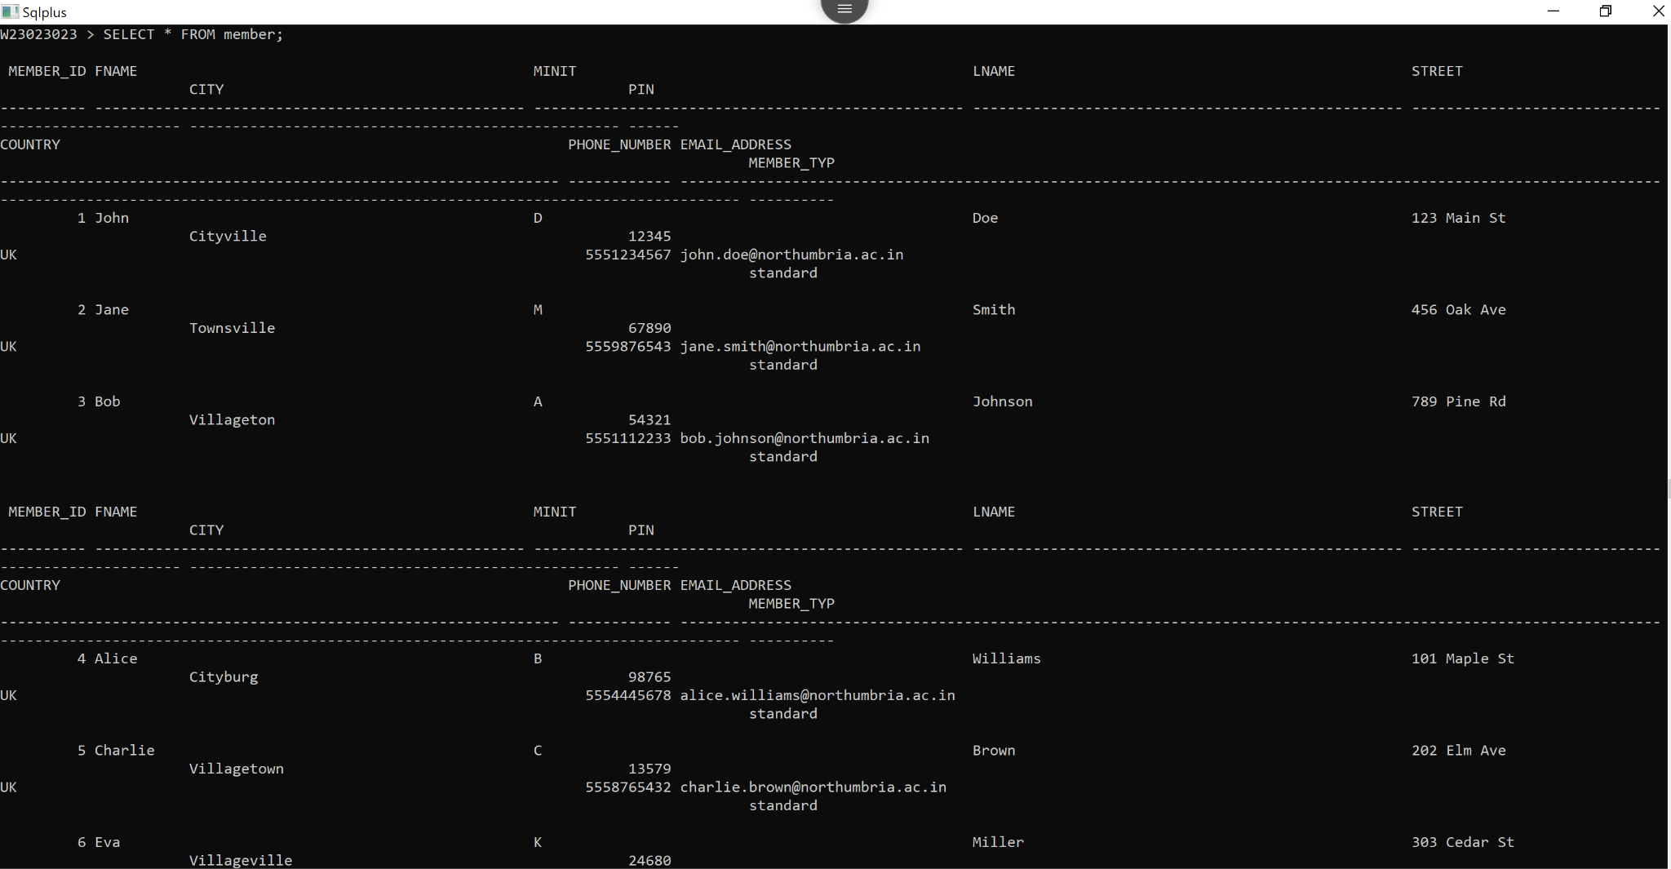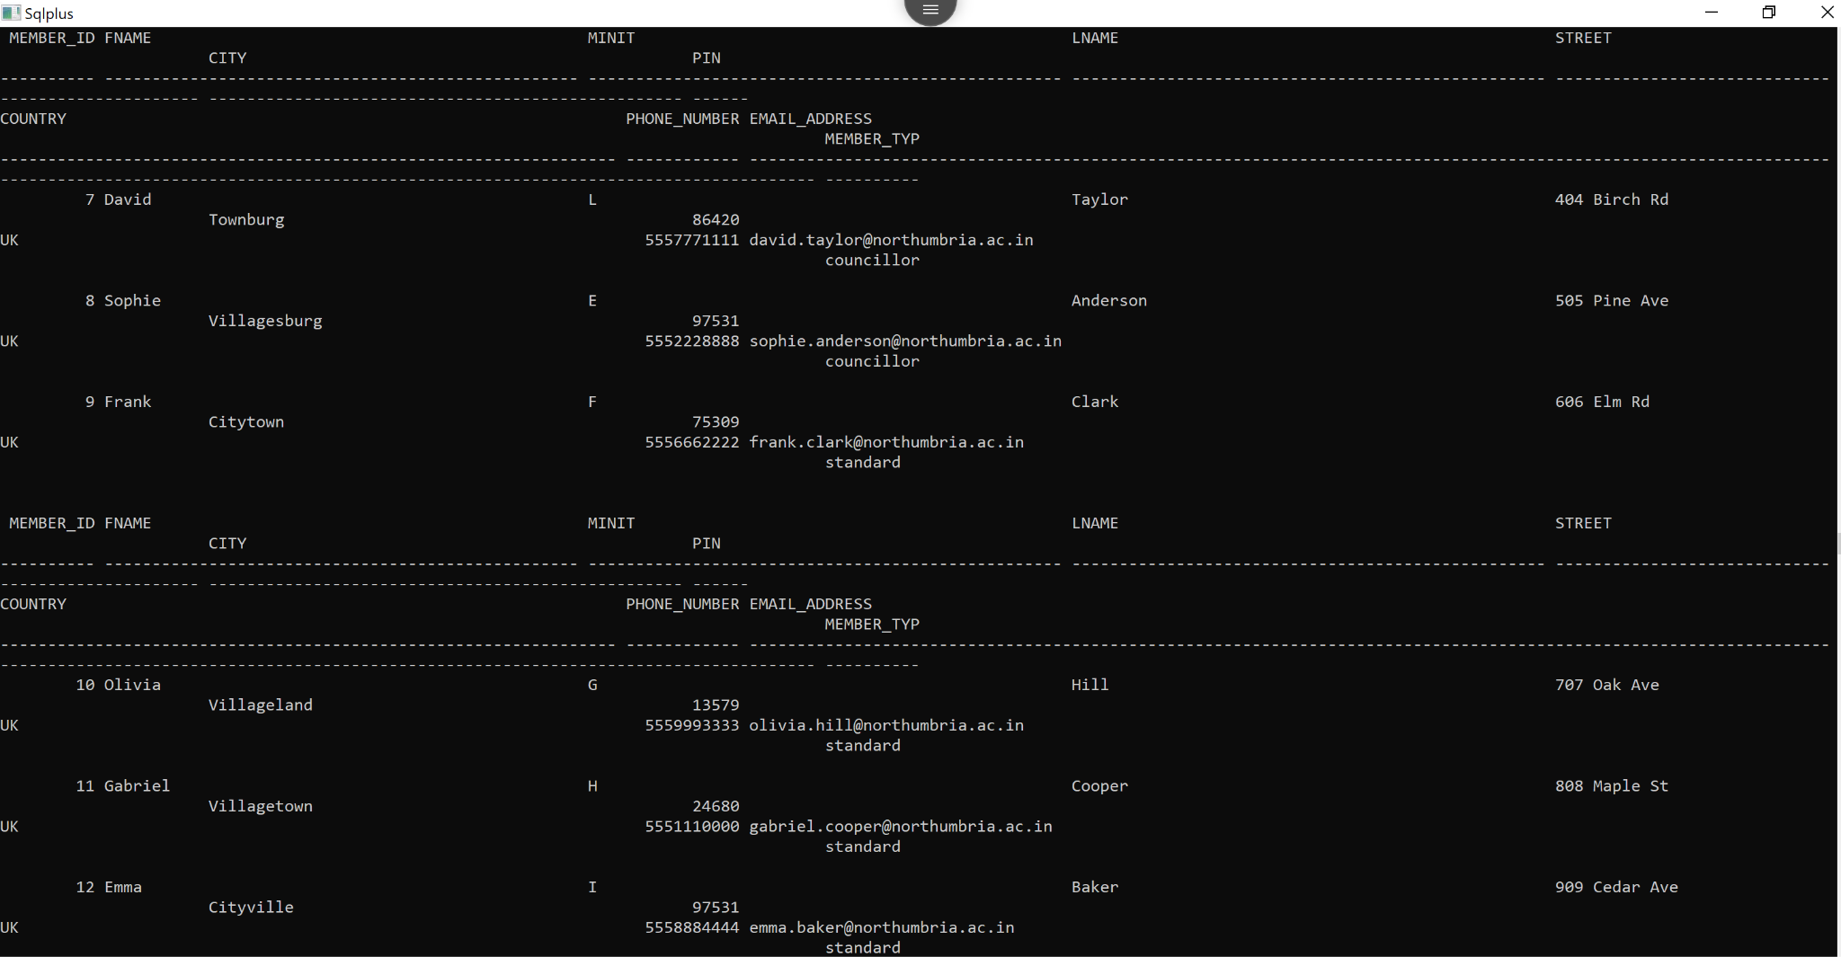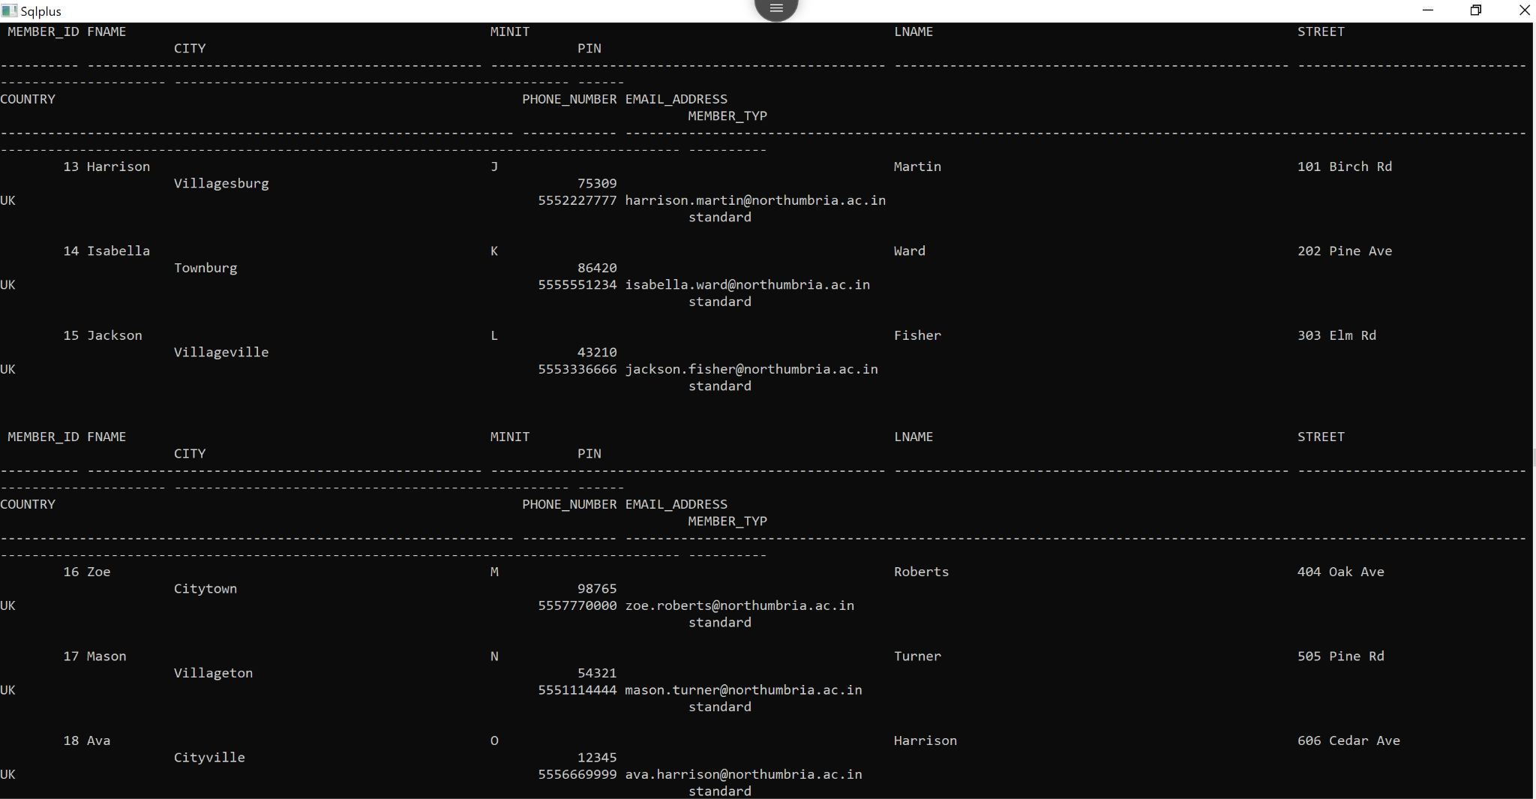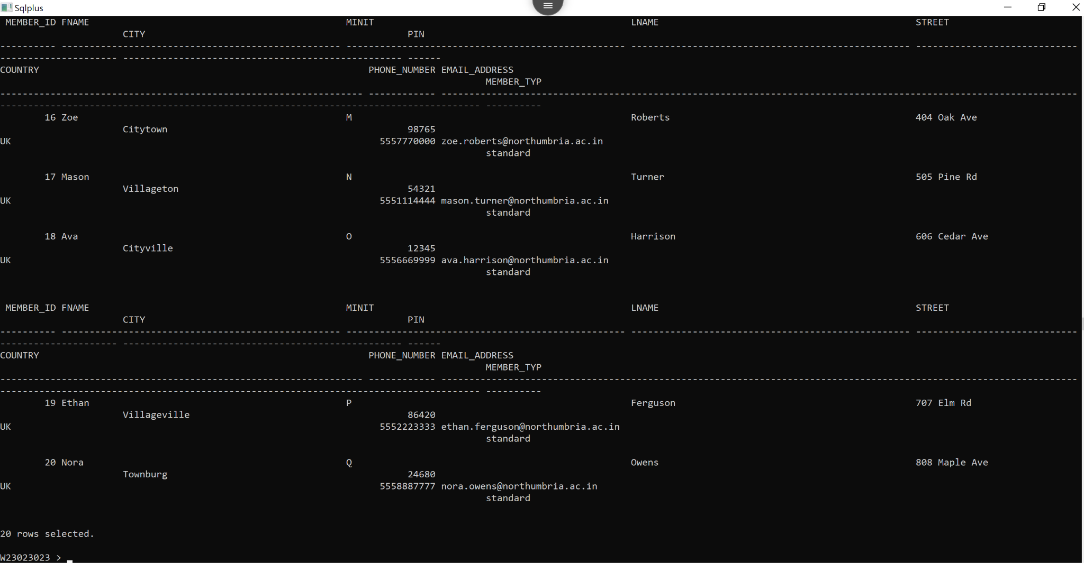**

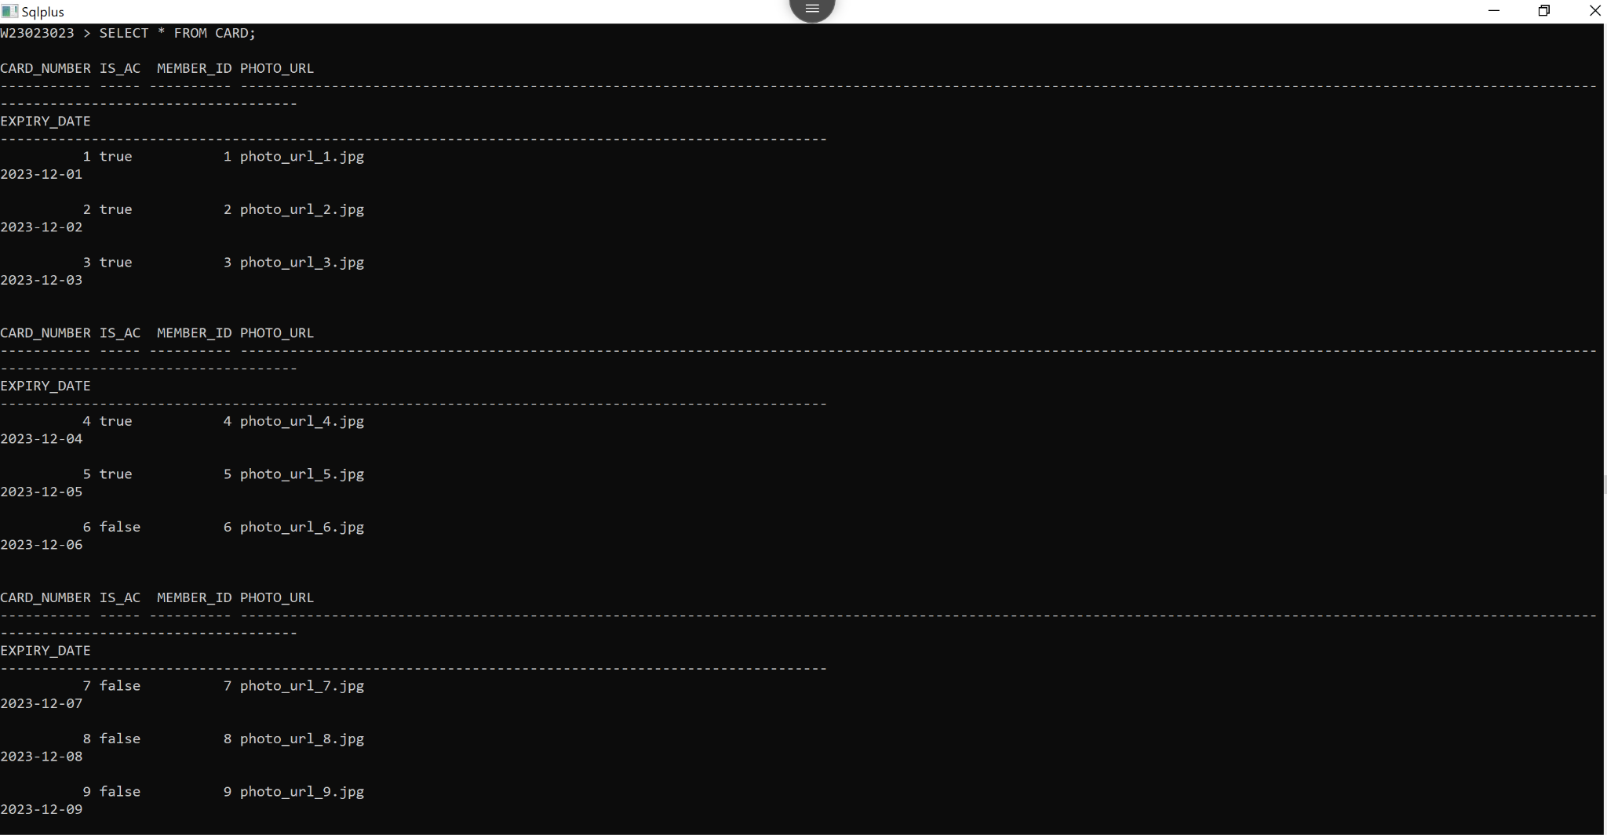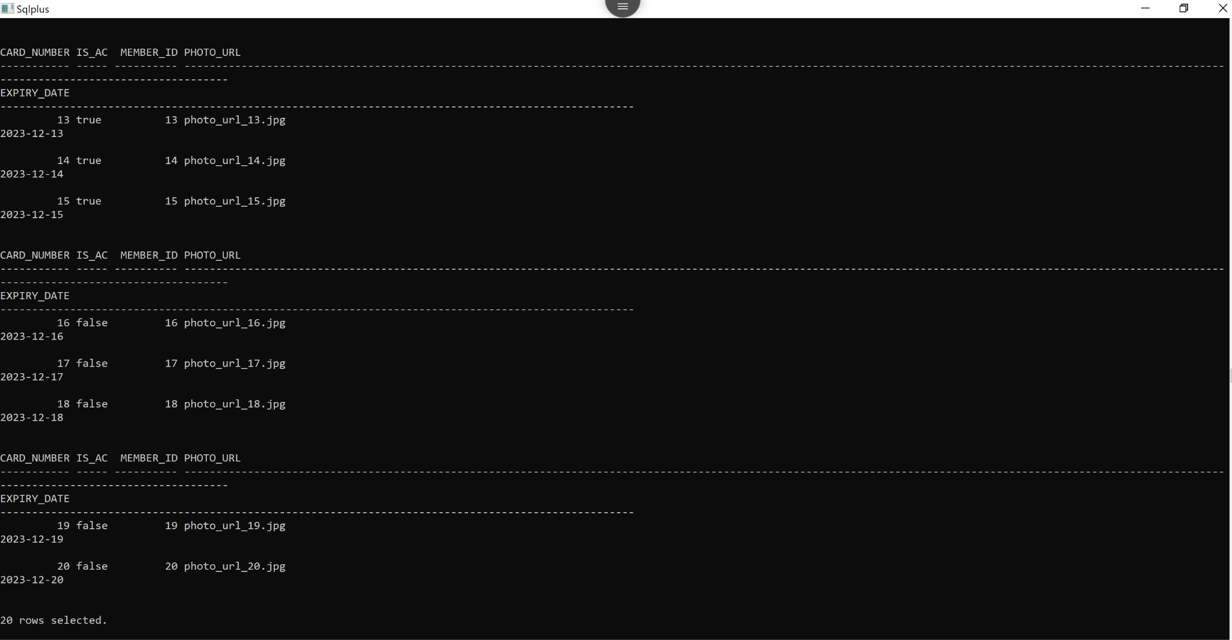

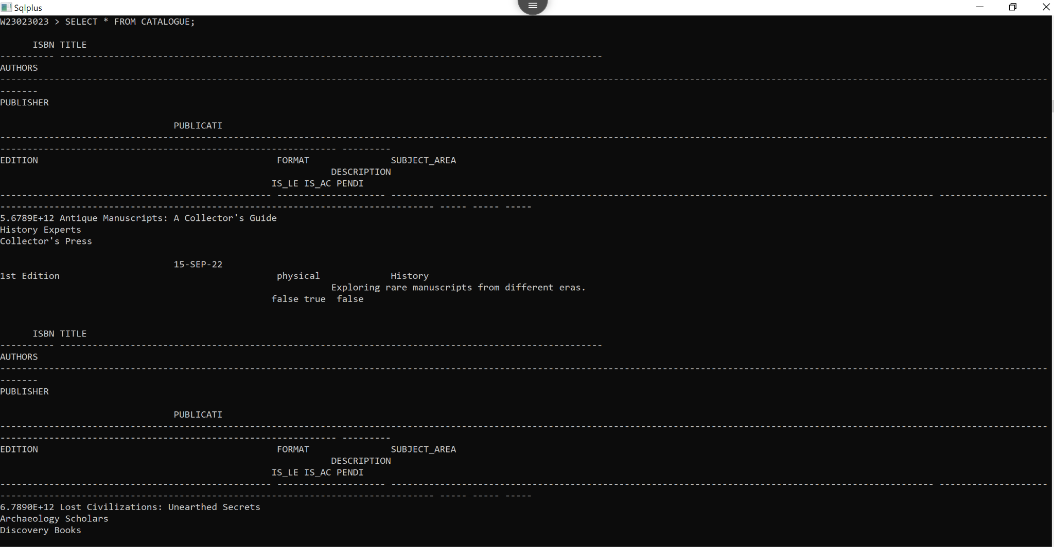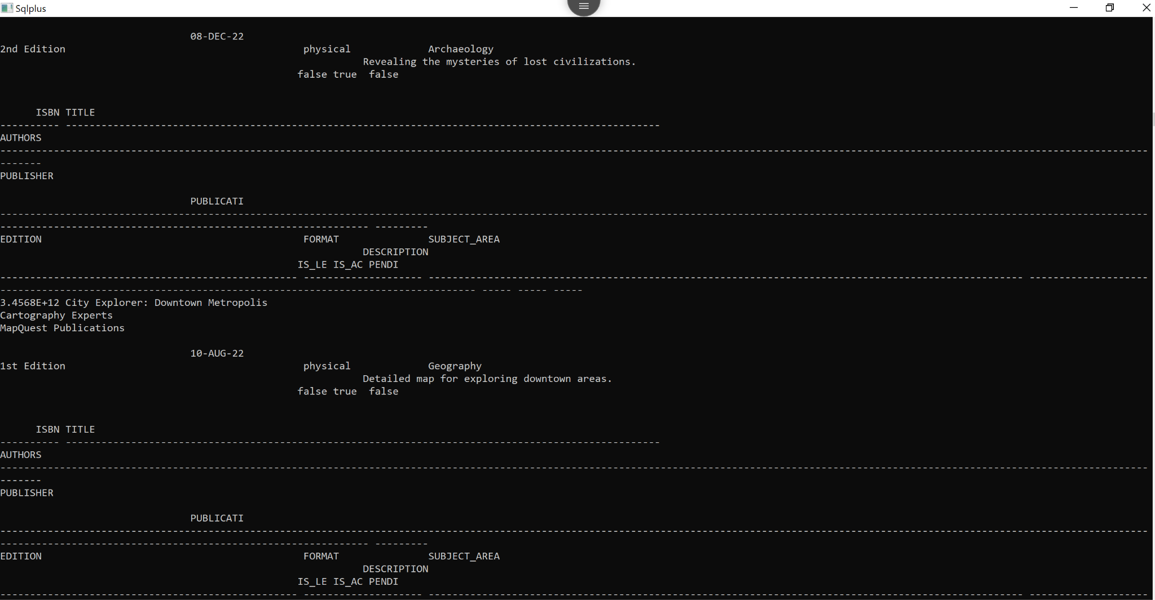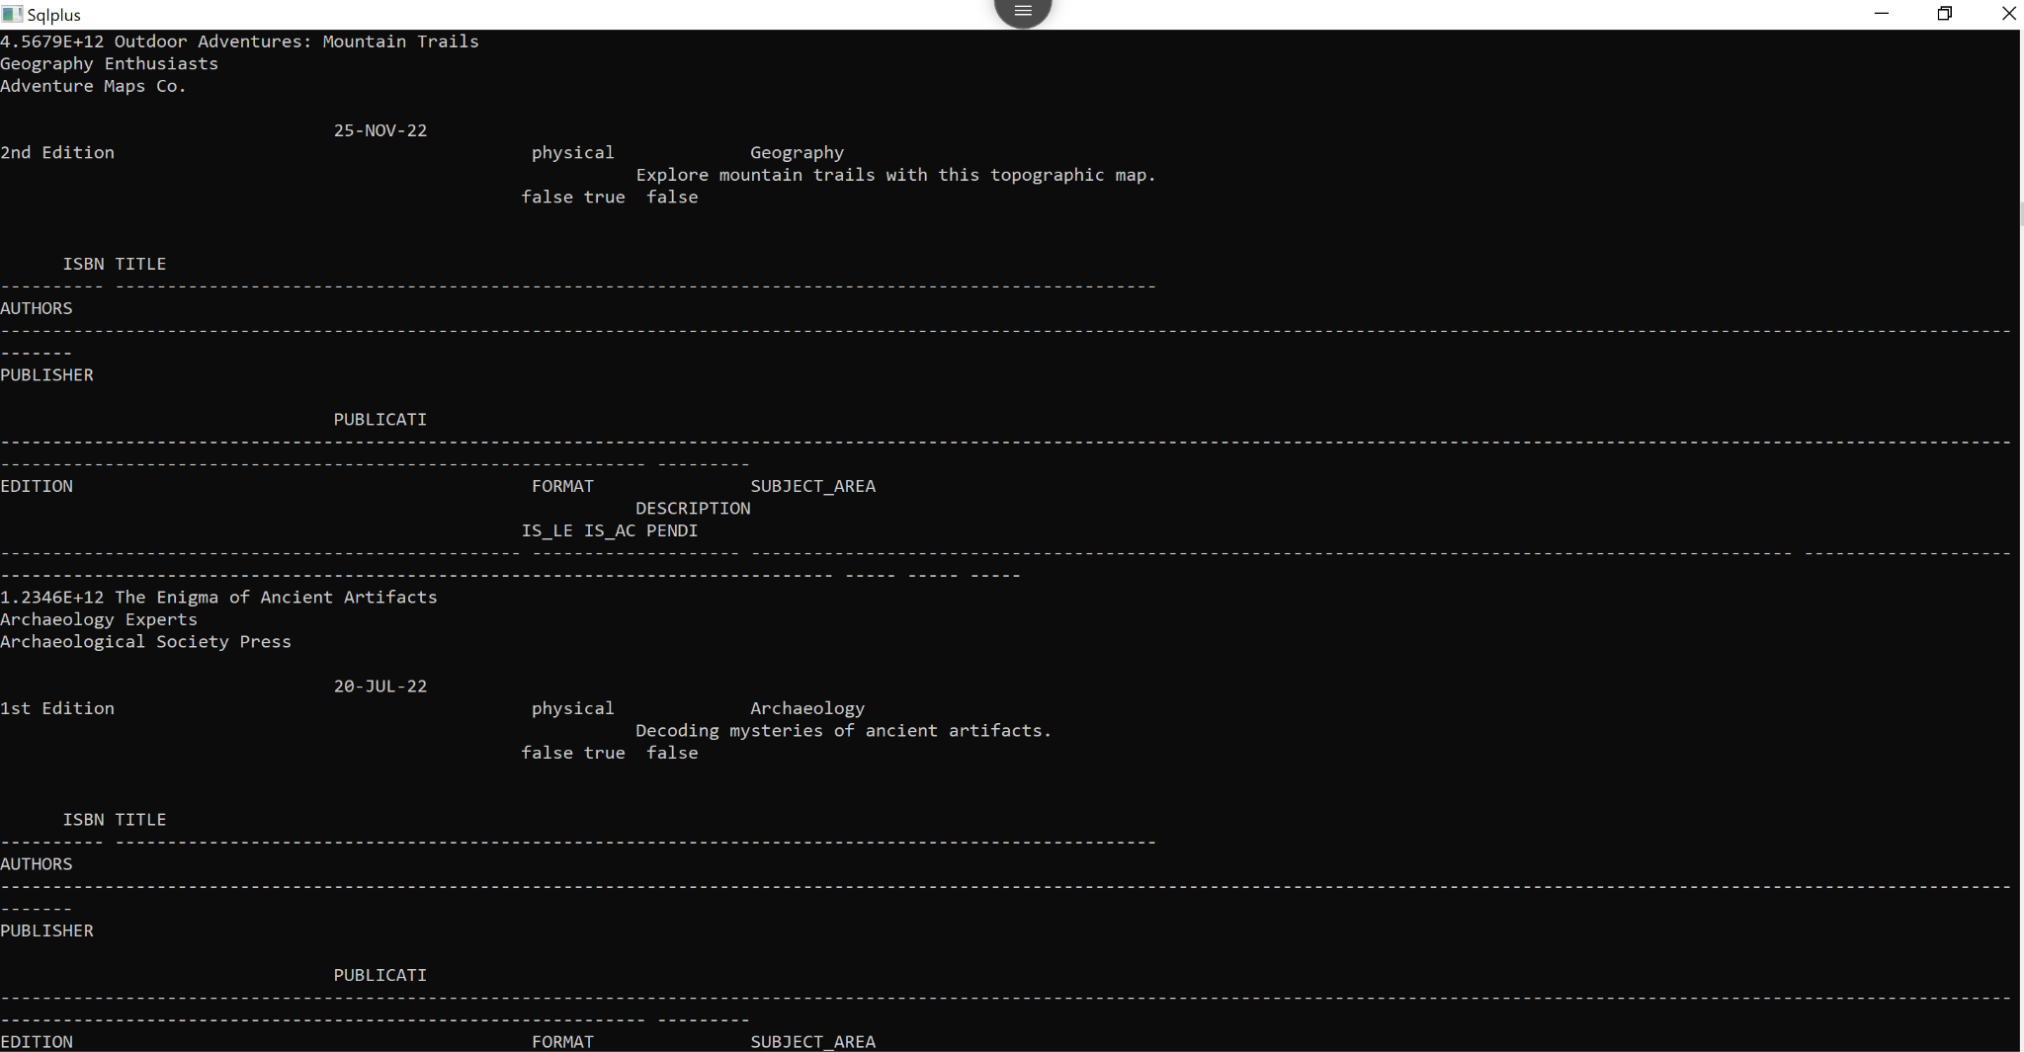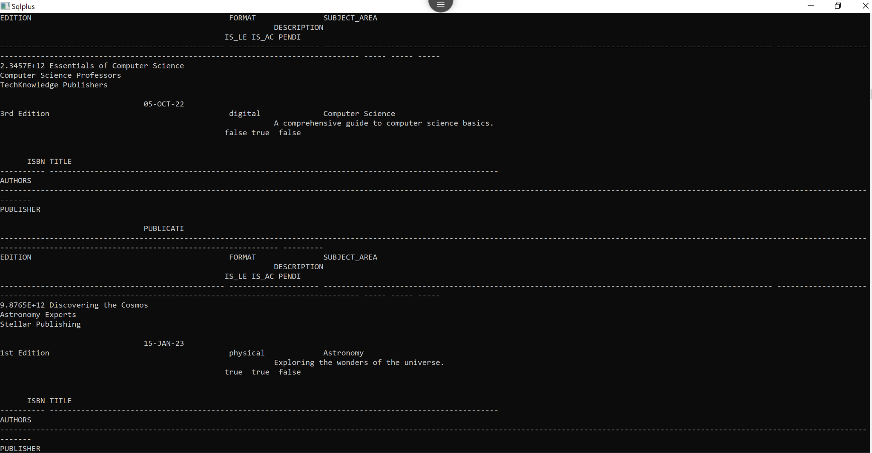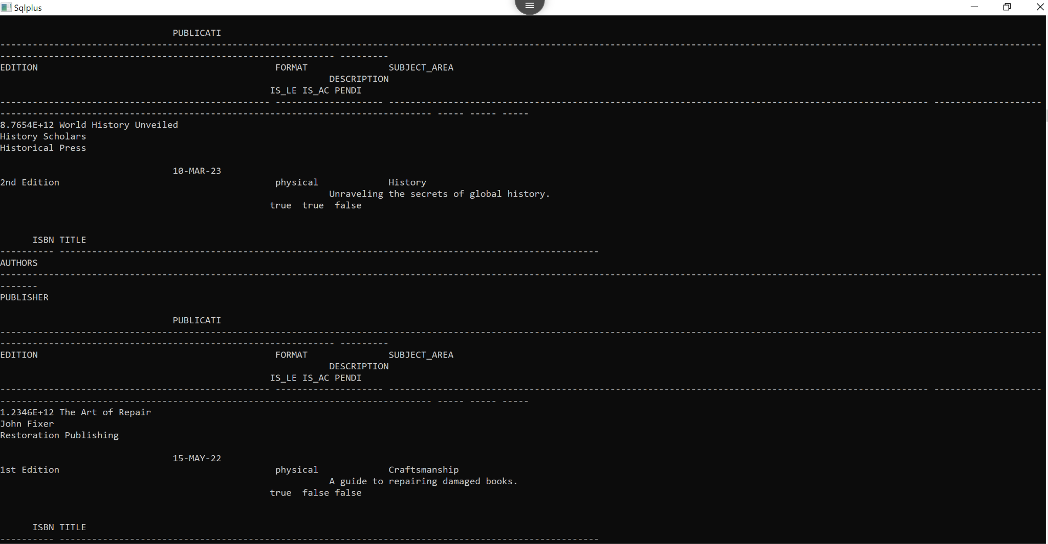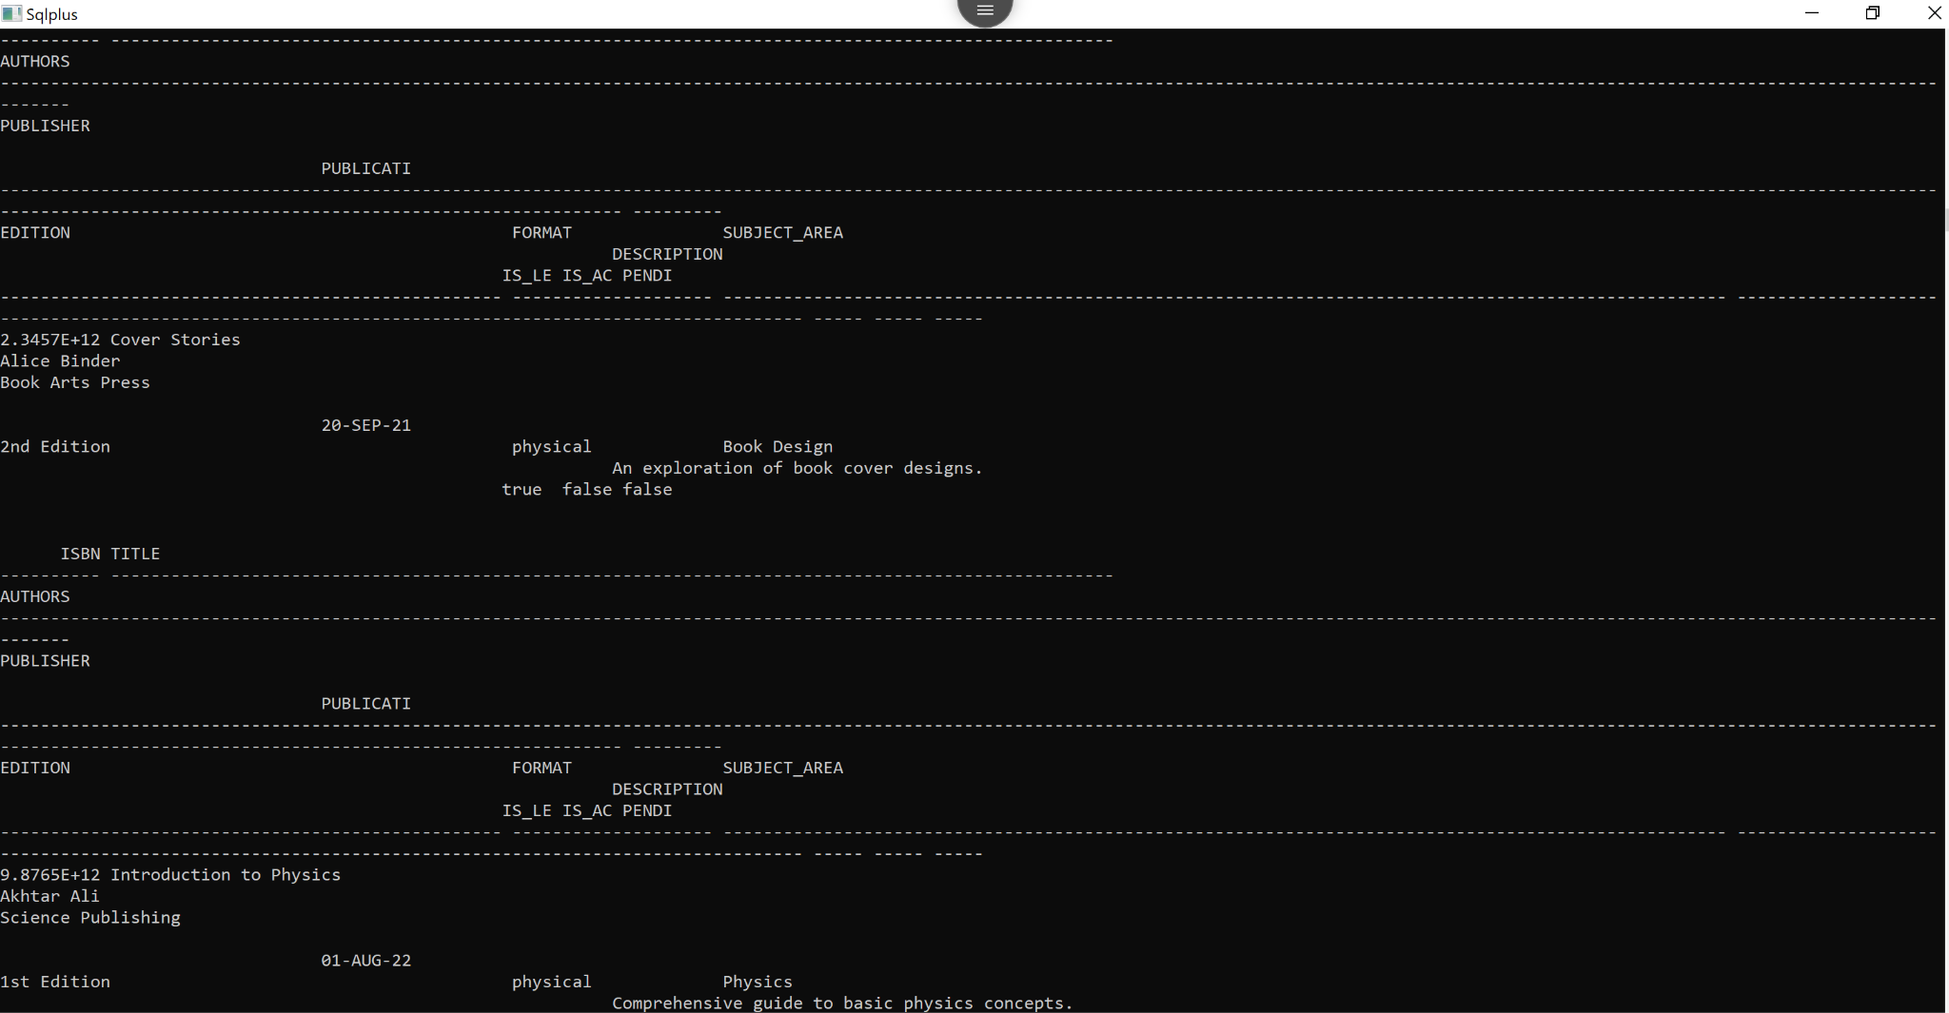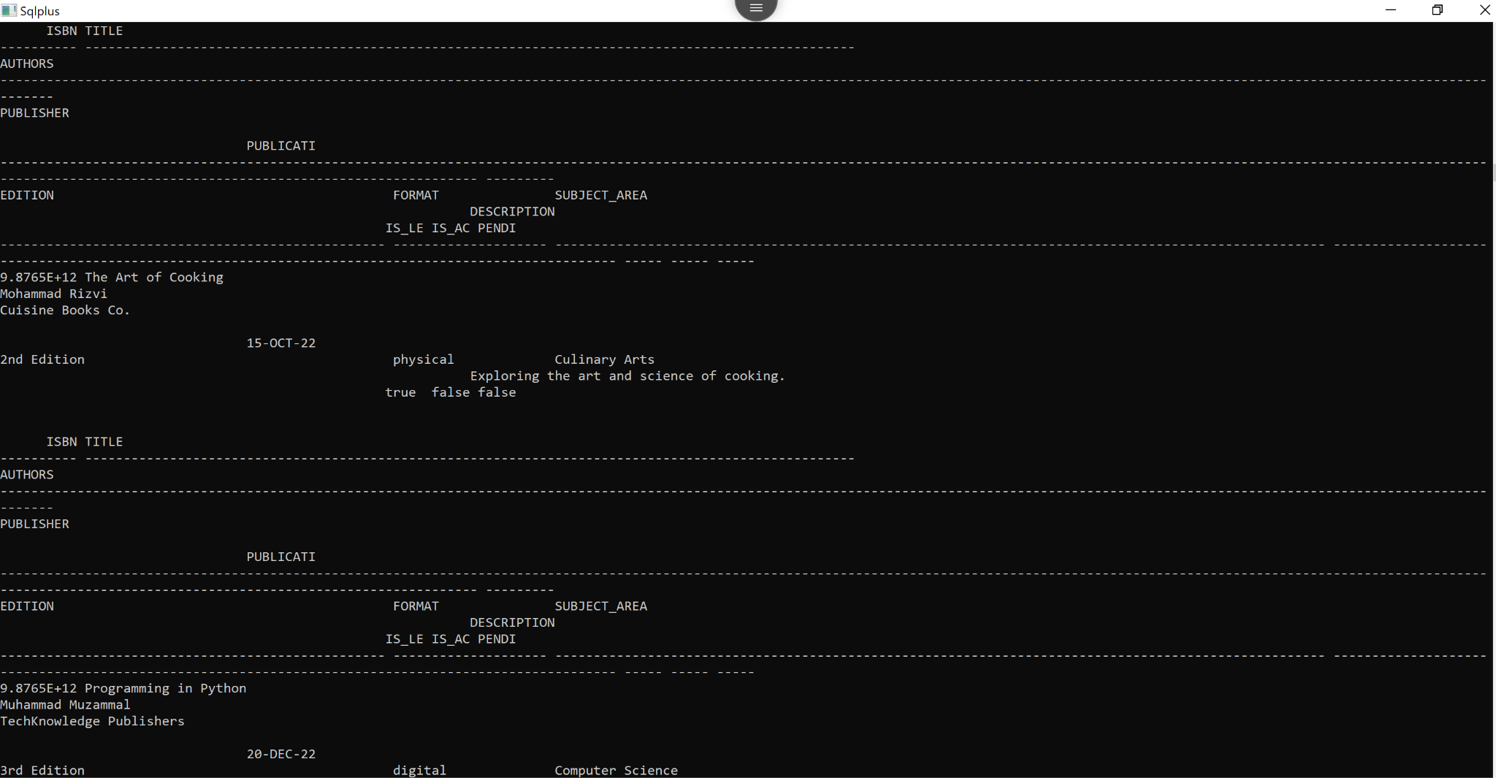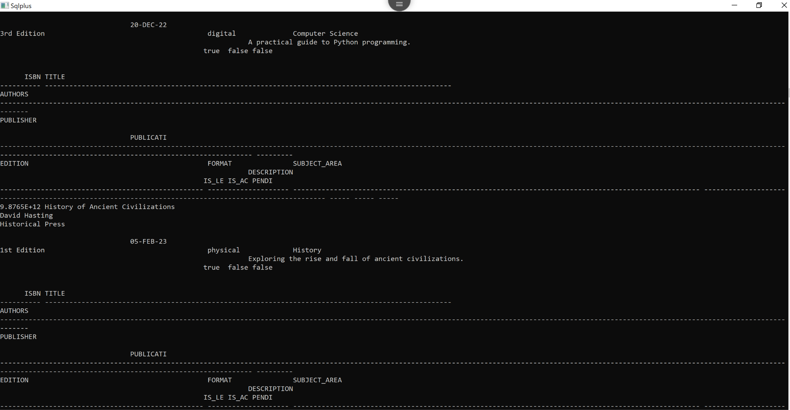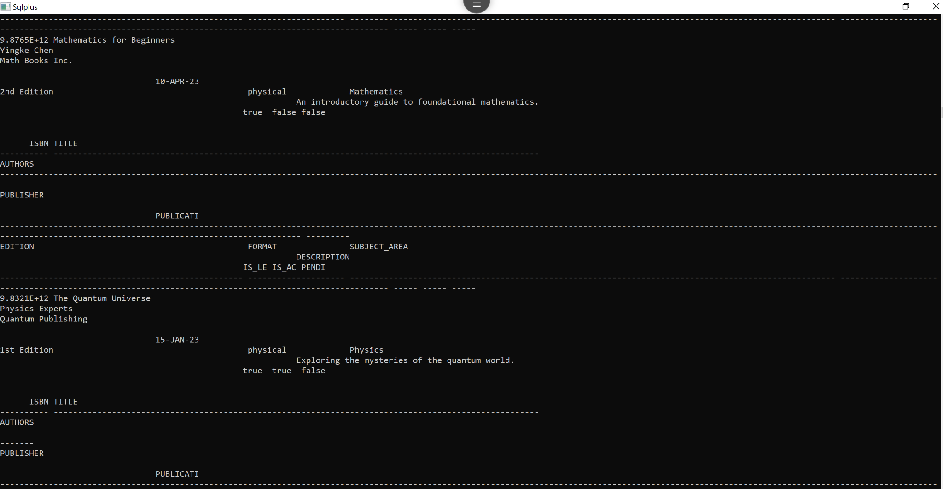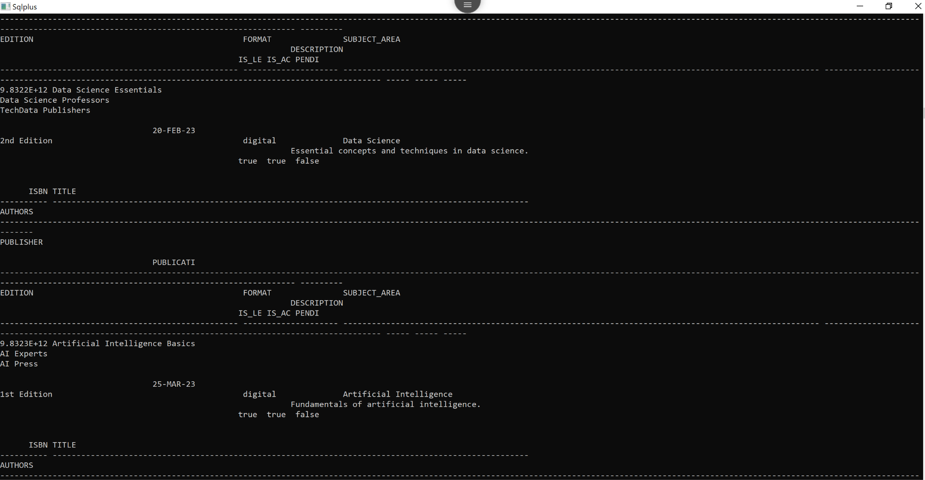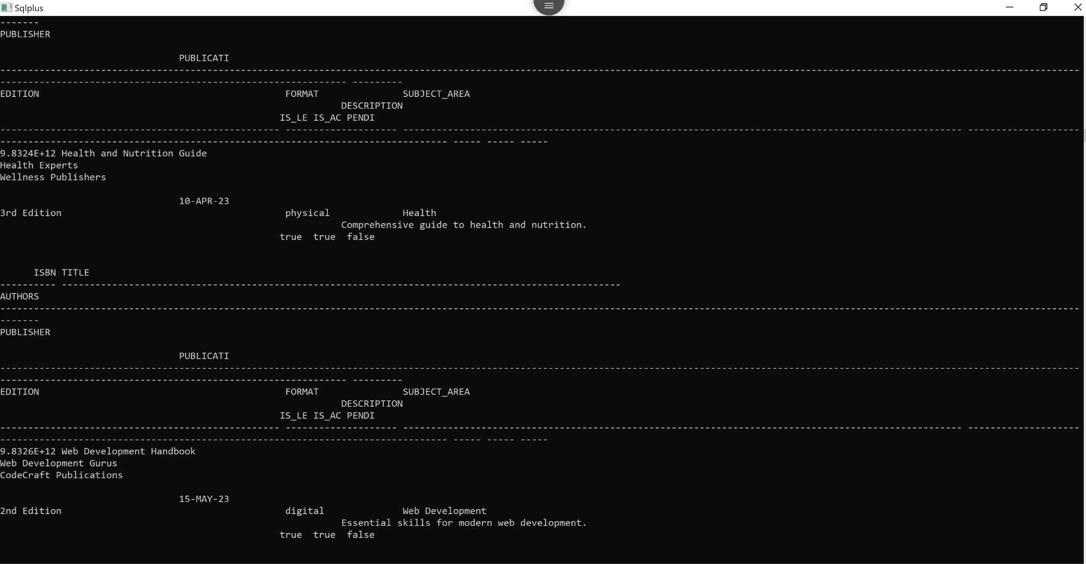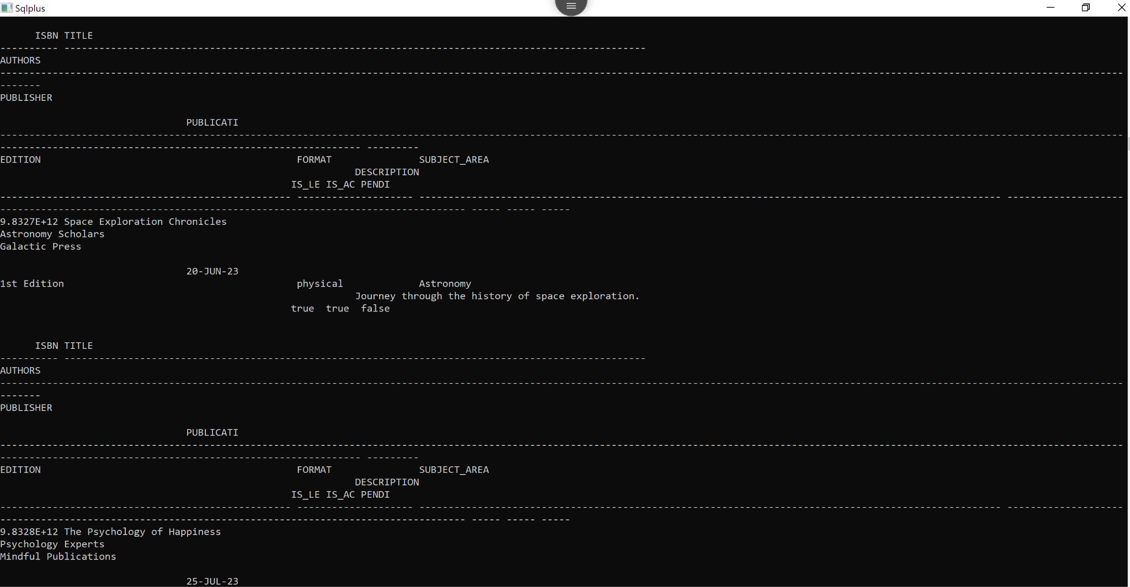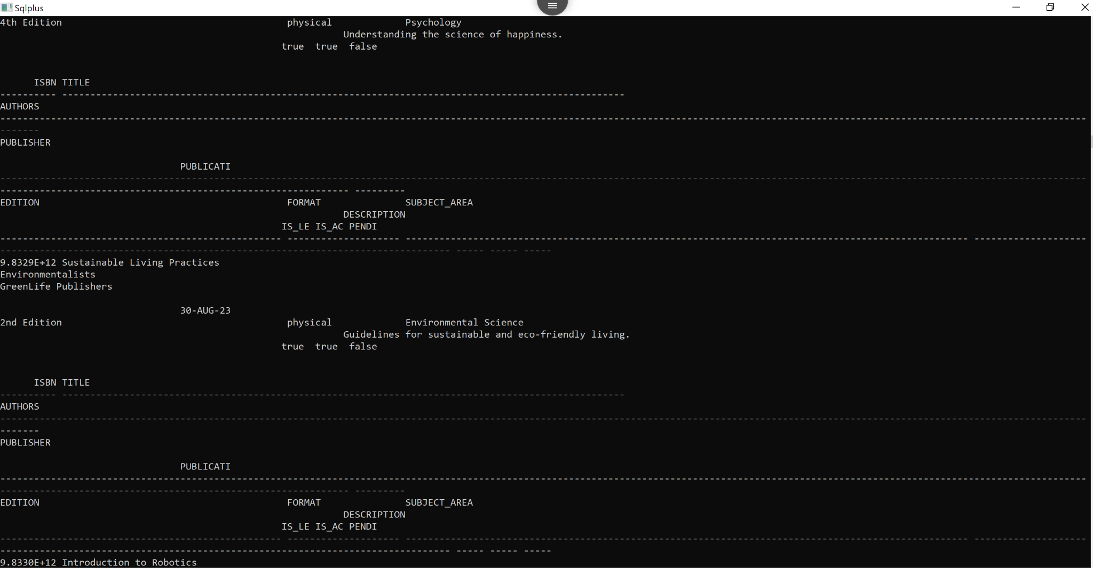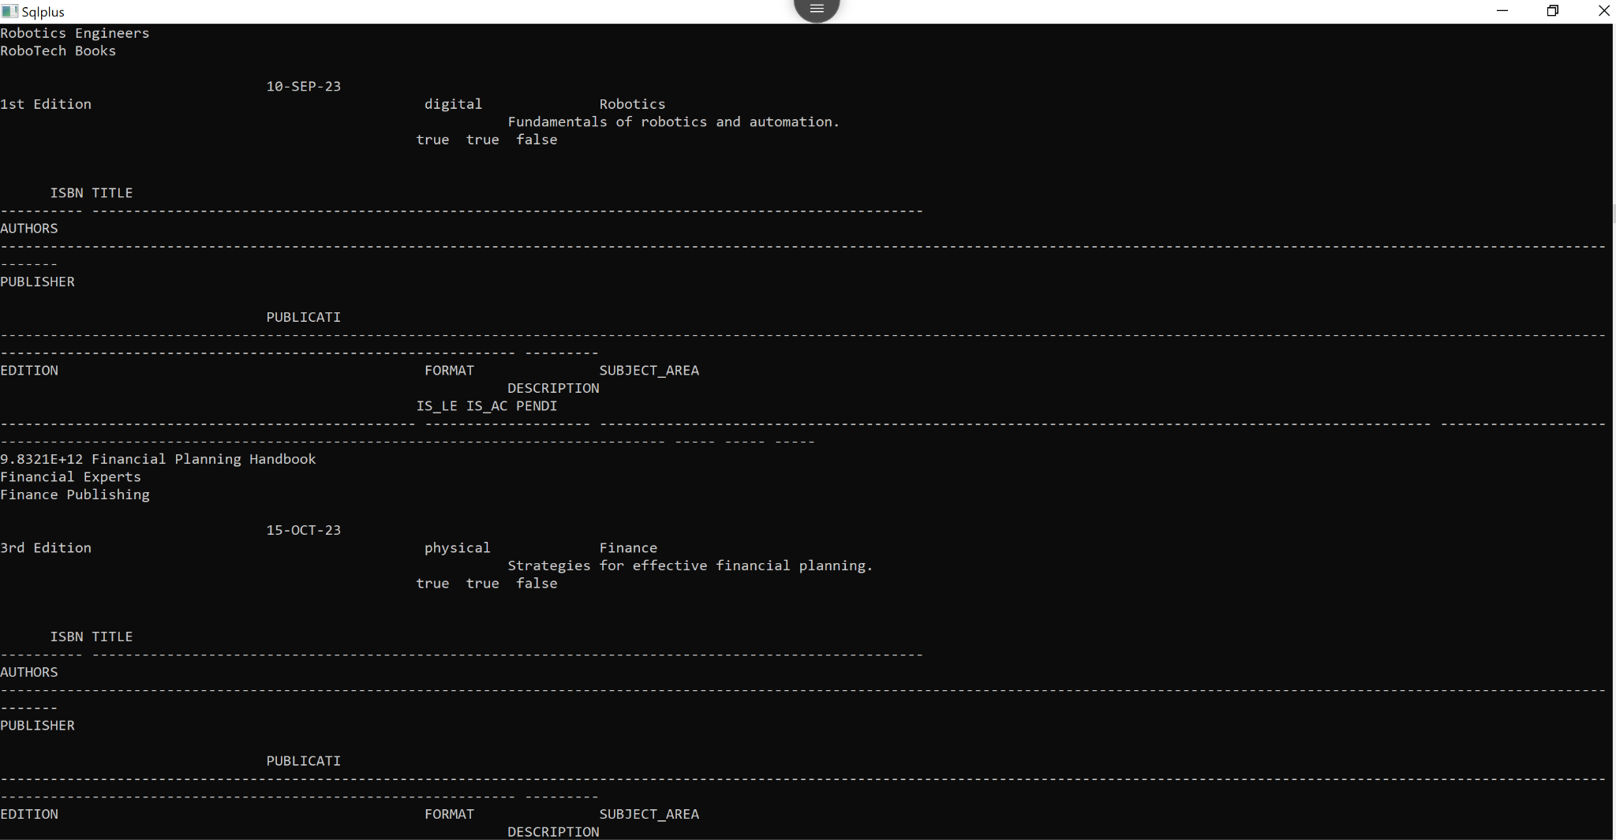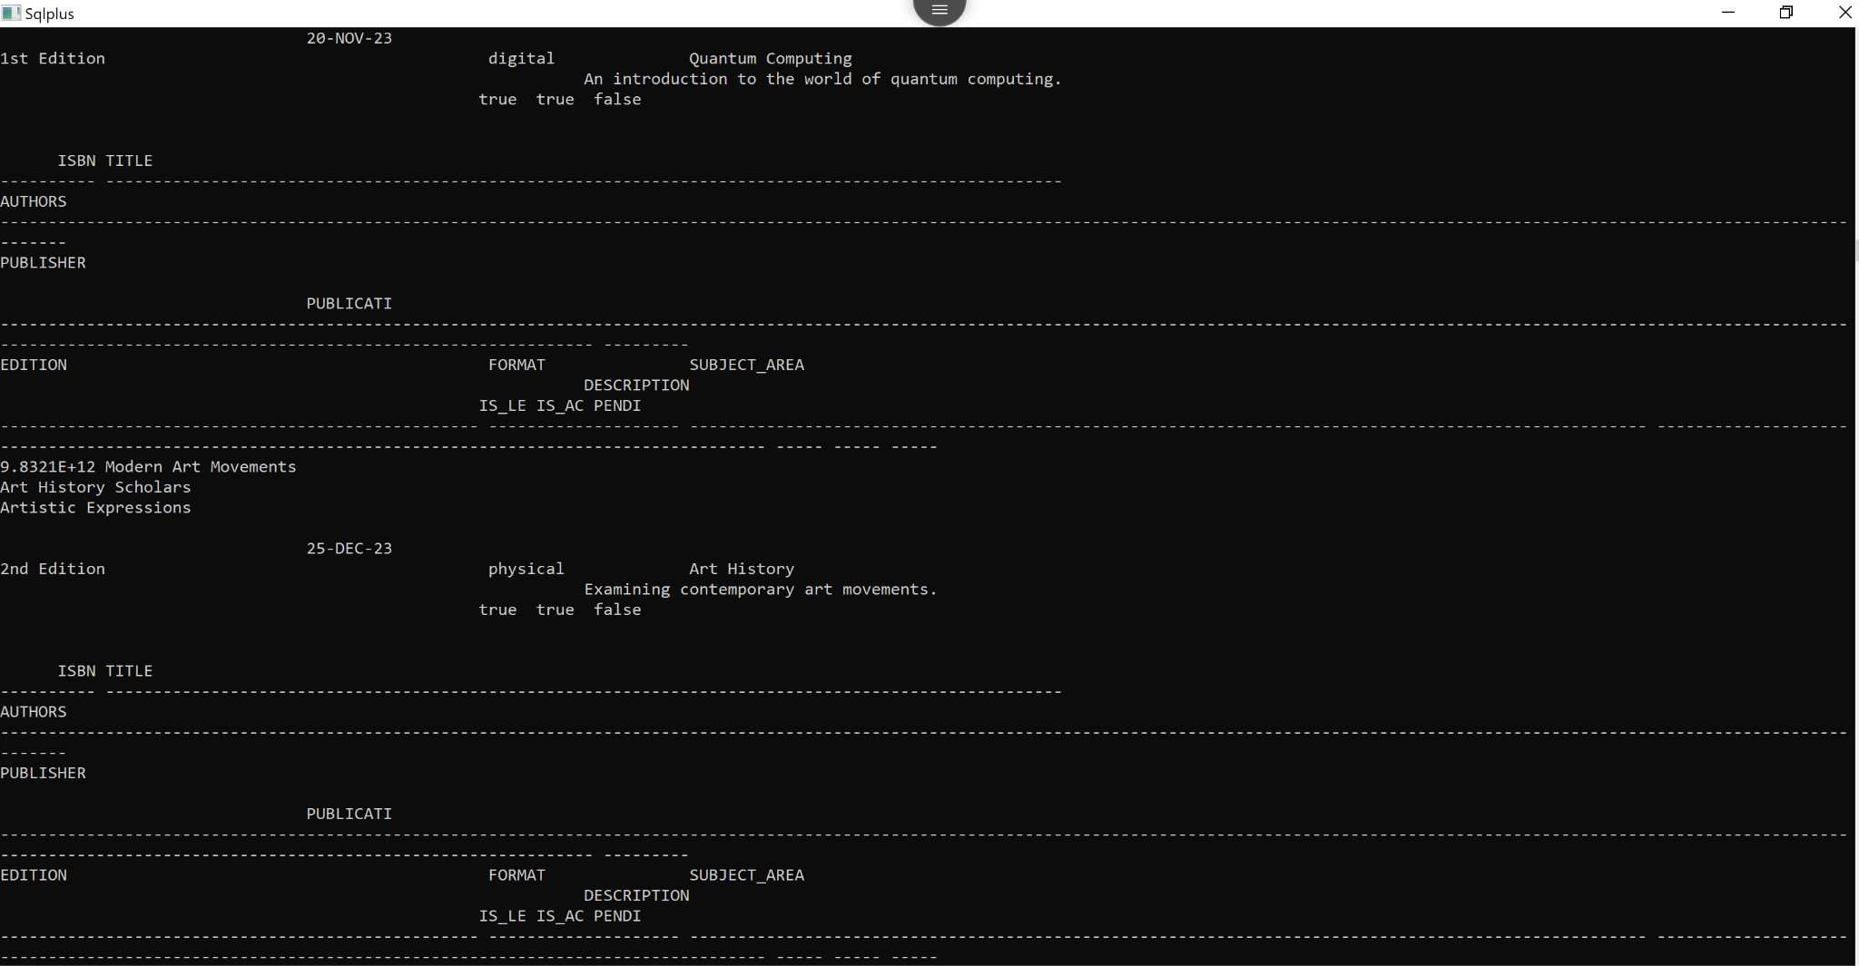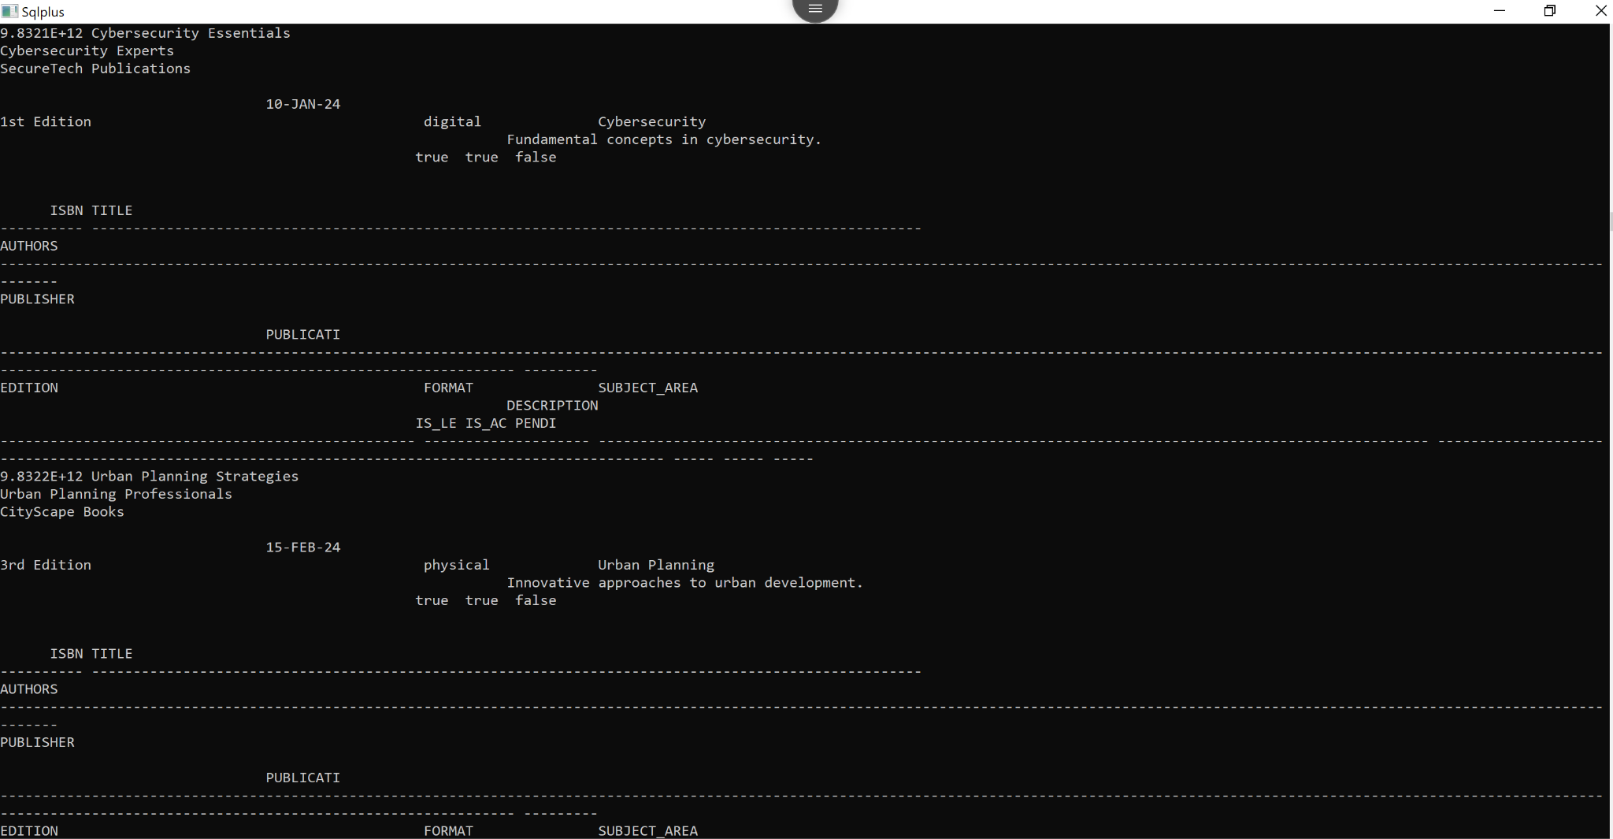

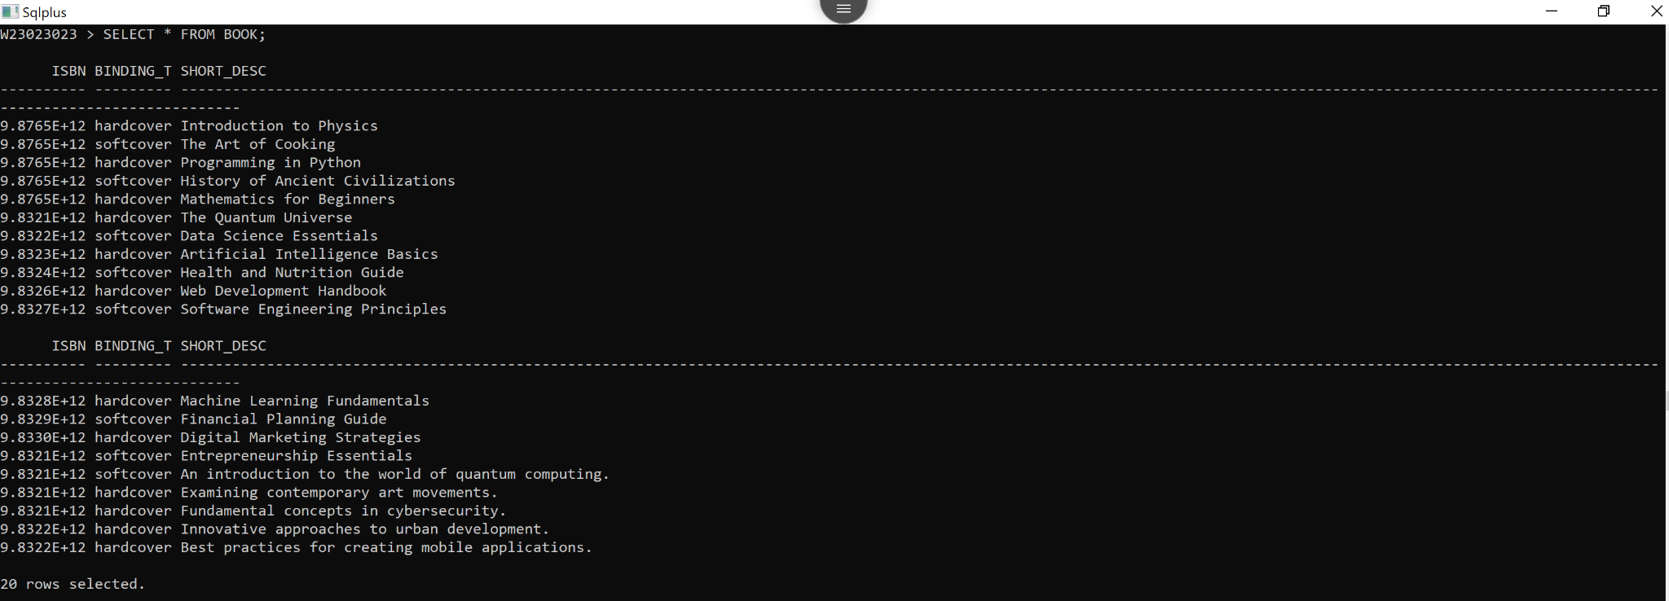

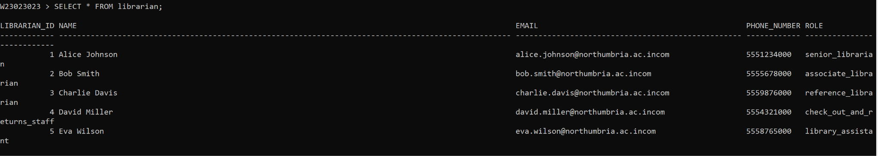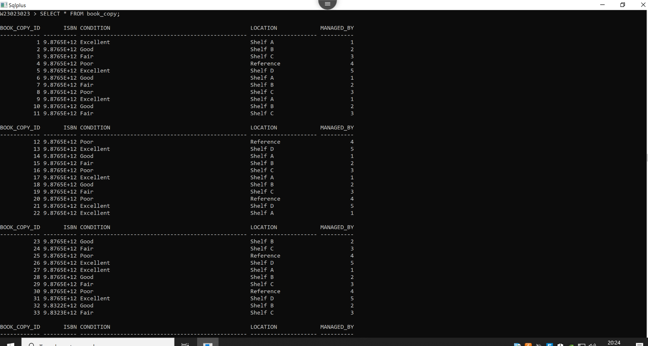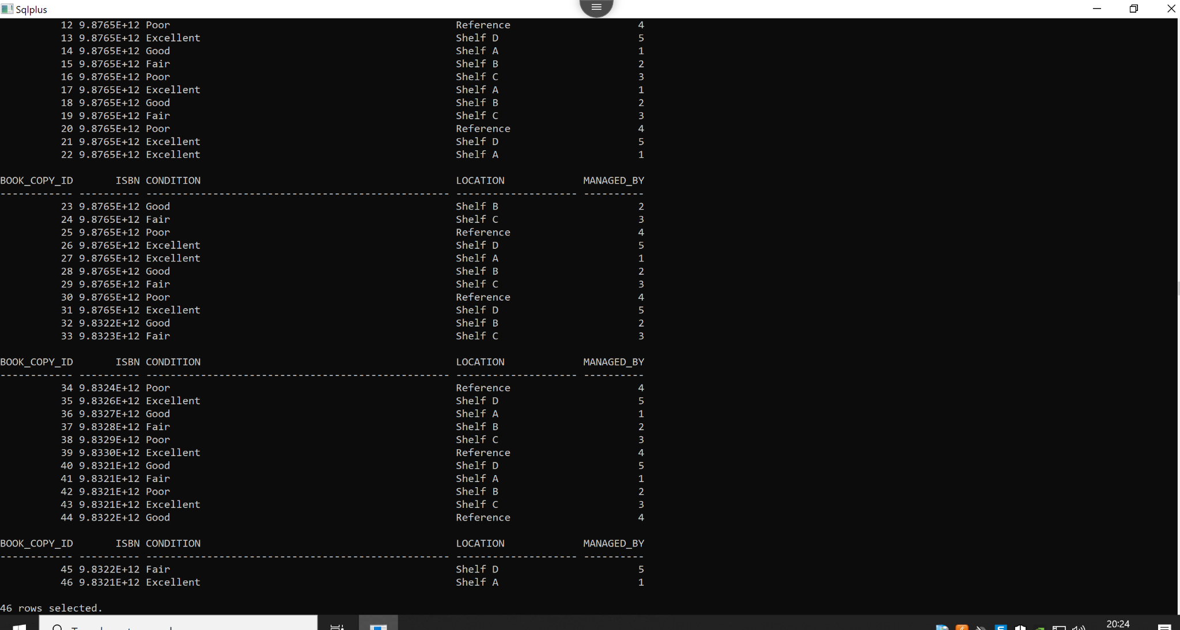

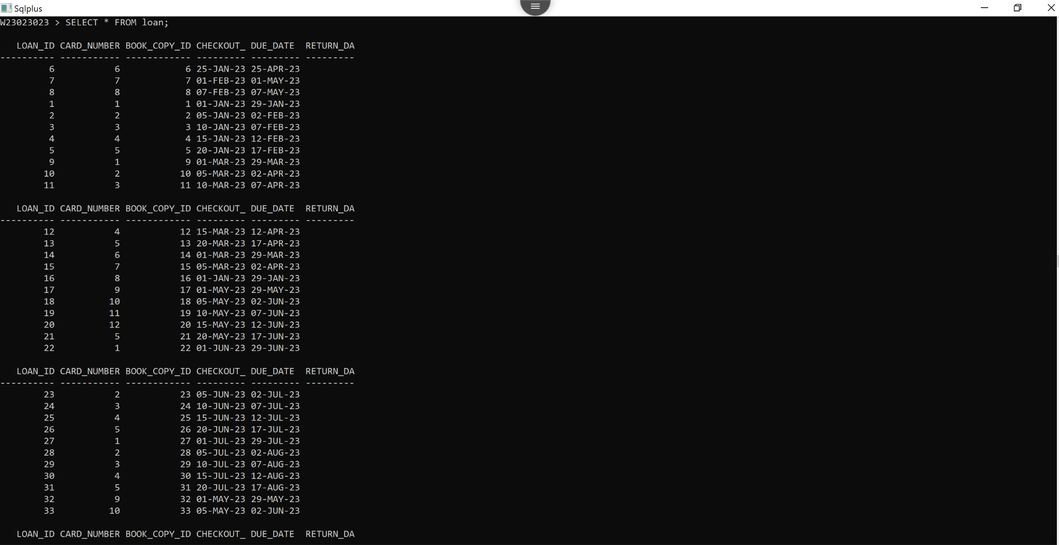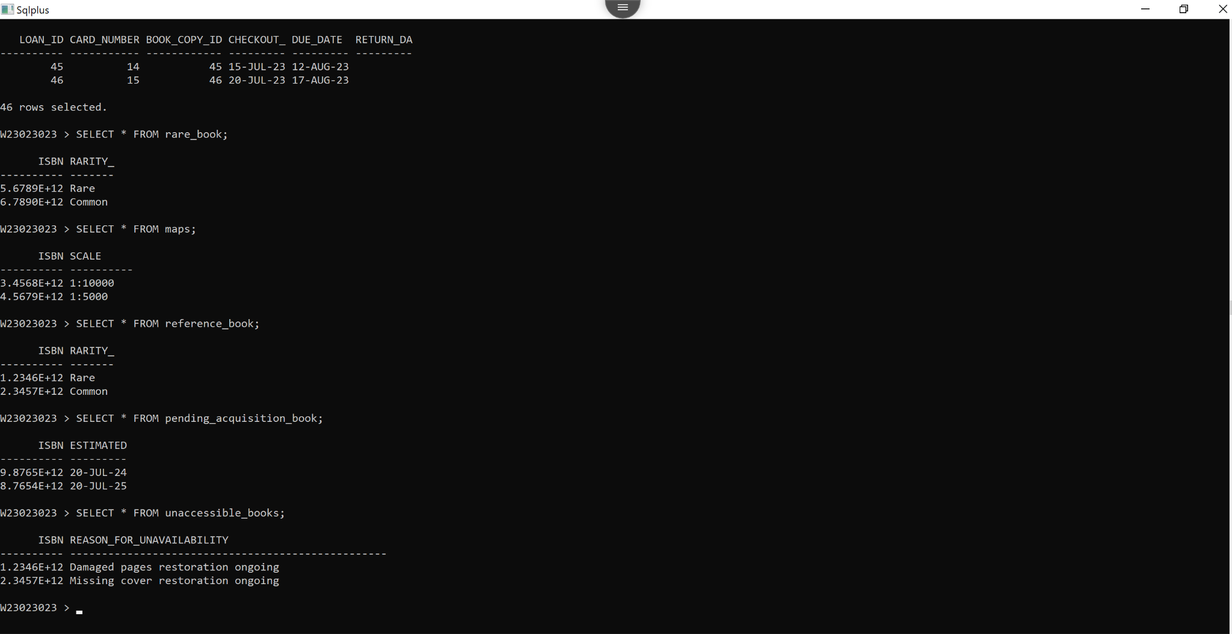

*(B) Answer the following queries (retrievals) using Relational Algebra and SQL.*

(10 marks)

1. Display details of the top 12 most frequent users (members) of the library with the number of books/titles/items they have borrowed in the past 12 months.

**Provide Relational Algebra expression below:**

|  |
| --- |
| *π*fname, lname, borrowed_books_count  (*σ*checkout_date≥ADD_MONTHS(SYSDATE, -12)  (*ρ*member_name, borrowed_books_count  (*γ*fname, lname, COUNT(loan_id) AS borrowed_books_count  (*ρ*member_id  (*C*⋈card_number  *L*))))) |

**Provide SQL query code as TEXT and output below (as image / screenshot / picture):**

|  |
| --- |
| SELECT  m.fname || ' ' || m.lname AS member_name,  COUNT(l.loan_id) AS borrowed_books_count FROM  loan l JOIN  card c ON l.card_number = c.card_number JOIN  member m ON c.member_id = m.member_id WHERE  l.checkout_date >= ADD_MONTHS(SYSDATE, -12) GROUP BY  m.fname, m.lname ORDER BY  borrowed_books_count DESC FETCH FIRST 12 ROWS ONLY; |

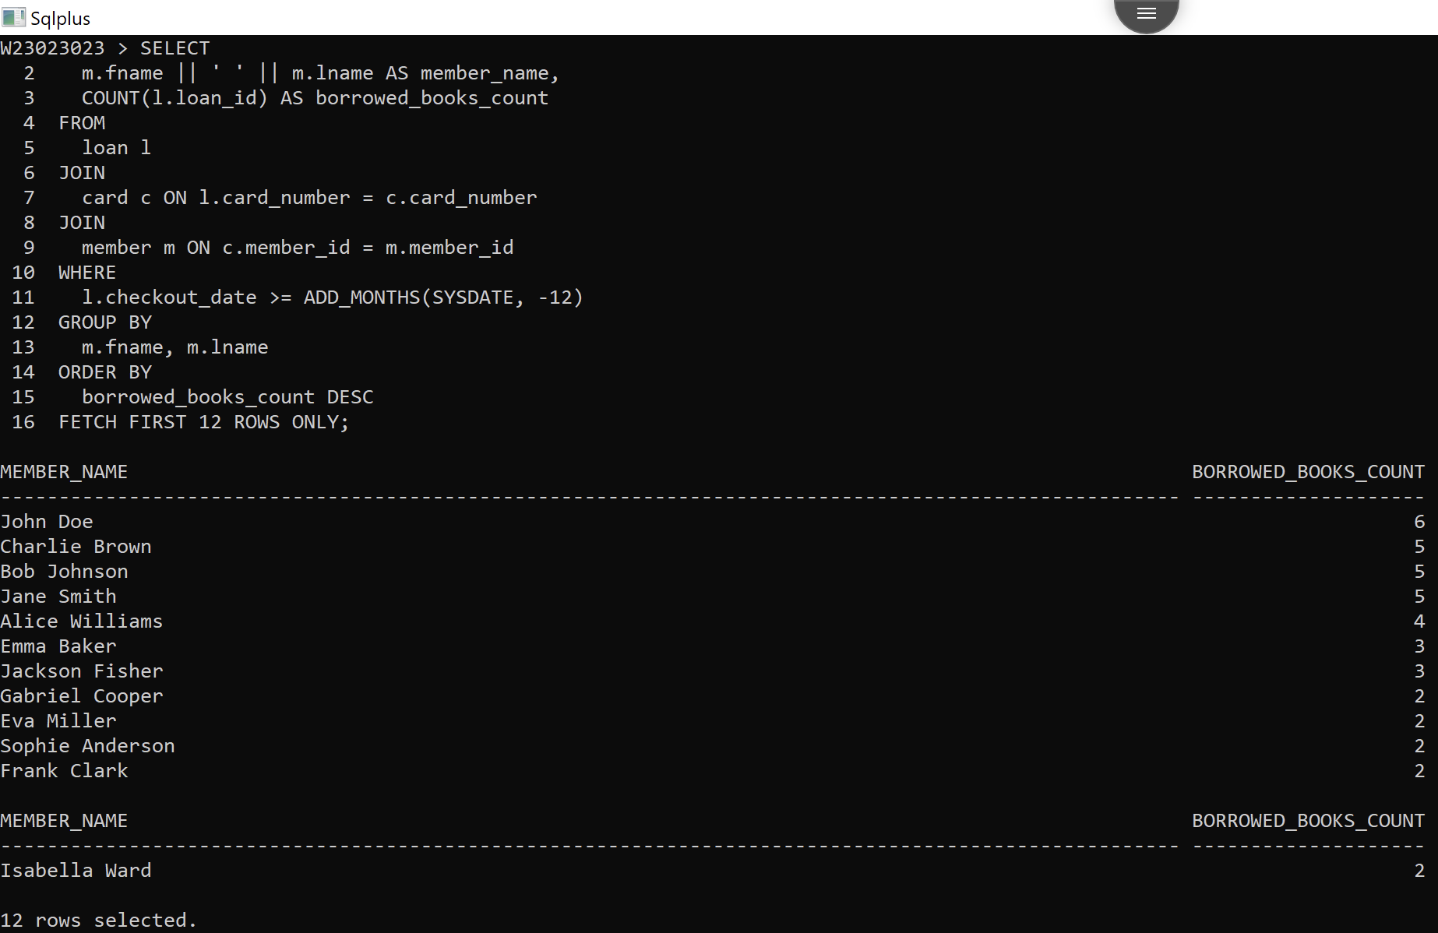

1. Display details of the top 15 most frequently borrowed titles/books/items of the BLS with the total number of borrowings in the past two financial years.

**Provide Relational Algebra expression below:**

|  |
| --- |
| *π*book_title, total_borrowings  (*σ*heckout_date≥ADD_MONTHS(TRUNC(SYSDATE, ’YY’), -24)  (*ρ*book_title, total_borrowings  ​(*γ*title, COUNT(loan_id) AS total_borrowings  (*ρ*isbn  (*C*⋈isbn  *B*)⋈book_copy_id  *BC*⋈book_copy_id  ​*L*)))) |

**Provide SQL query code as TEXT and output below (as image / screenshot / picture):**

|  |
| --- |
| SELECT  c.title AS book_title,  COUNT(l.loan_id) AS total_borrowings FROM  loan l JOIN  book_copy bc ON l.book_copy_id = bc.book_copy_id JOIN  book b ON bc.isbn = b.isbn JOIN  catalogue c ON b.isbn = c.isbn WHERE  l.checkout_date >= ADD_MONTHS(TRUNC(SYSDATE, 'YY'), -24) -- Start of the two financial years GROUP BY  c.title ORDER BY  total_borrowings DESC FETCH FIRST 15 ROWS ONLY; |

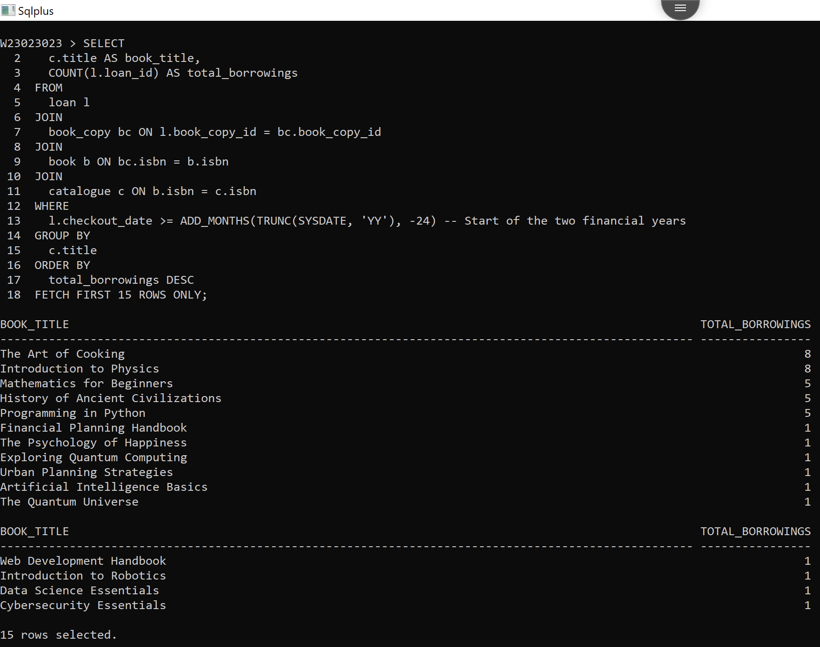

**Part 3 (35 marks)**

This part is based on your answer / solution to Part 1 (A), i.e., conceptual design of the database for the BLS scenario.

*(A) Choose and justify what aspects of BLS conceptual design would be better off if implemented using object-relational database; then provide logical design and implementation of the subset of the BLS using ER/EER to object-relational mapping and object-relational features of Oracle Database System (Kannan); populate the object-tables with sample data and demonstrate your choice of design and implementation by running two complex queries on your object-tables.*

(20 marks)

**Answer Part 3 A**

1. **Provide below your choice and justification of what aspects (subset) of the BLS conceptual design from Part 1.A you would like to implement using object relational databases (2 marks)**

I would like to implement Ord design in the member_card, loan, and book_copy table because:  
1. Most of the transactions happen in between those tables, and if I need to generate a report of library performance, then these tables are the most important to consider.  
2. The loan table will be updated most of the time, due to which the number of data points in it will be high, and when the user needs to send mail, we will generally make a selection query on the loan table, so it is a must and a suitable choice to convert into an ORD.

1. **Provide below the logical design for your chosen subset using ER/EER to object-relational mapping (2 marks)**
2. **Provide below the SQL query code as TEXT and output below (as image / screenshot / picture) for implementing your above logical object-relational design (8 marks)**

|  |
| --- |
| **-- CREATING  create type loan_t; create type loan_nt_type as table of REF loan_t;  create type card_member_t as object ( card_number number(4), member_id varchar(4), name varchar(100), card_exp_date date, is_active varchar(5), loans loan_nt_type );  create type book_copy_t; create type book_copy_nt_type as table of REF book_copy_t;  create or replace type loan_t as object  ( loan_id number(5), return_date date, checkout_date date, card_member_ref ref card_member_t, loan_book_copy book_copy_nt_type );  create or replace type book_copy_t as object ( book_copy_id number(4), isbn number(13), title varchar(100), loan_for_ref REF loan_t );    create table card_member_tab of card_member_t ( primary key (card_number) ) nested table loans store as loans_nt_tab;  create table loan_tab of loan_t ( primary key (loan_id), foreign key (card_member_ref) references card_member_tab ) nested table loan_book_copy store as loan_book_copy_tab;   create table book_copy_tab of book_copy_t ( primary key (book_copy_id), foreign key (loan_for_ref) references loan_tab );** |

1. **Provide below the SQL query code as TEXT and the output below (as image / screenshot / picture) for populating your above object-relational subset of the BLS database (4 marks)**

|  |
| --- |
| **-- Insert into card_member_tab INSERT INTO card_member_tab VALUES (  card_member_t(3, 'M3', 'Alice Johnson', TO_DATE('2023-12-31', 'YYYY-MM-DD'), 'Yes', loan_nt_type()) );  INSERT INTO card_member_tab VALUES (  card_member_t(4, 'M4', 'Bob Williams', TO_DATE('2023-12-31', 'YYYY-MM-DD'), 'Yes', loan_nt_type()) );  INSERT INTO card_member_tab VALUES (  card_member_t(5, 'M5', 'Charlie Brown', TO_DATE('2023-12-31', 'YYYY-MM-DD'), 'Yes', loan_nt_type()) );  INSERT INTO card_member_tab VALUES (  card_member_t(6, 'M6', 'Diana Johnson', TO_DATE('2023-12-31', 'YYYY-MM-DD'), 'Yes', loan_nt_type()) );  -- Insert into loan_tab INSERT INTO loan_tab VALUES (  loan_t(103, TO_DATE('2023-03-20', 'YYYY-MM-DD'), TO_DATE('2023-03-01', 'YYYY-MM-DD'), (SELECT REF(c) FROM card_member_tab c WHERE c.card_number = 3), book_copy_nt_type(NULL)) );  INSERT INTO loan_tab VALUES (  loan_t(104, TO_DATE('2023-04-25', 'YYYY-MM-DD'), TO_DATE('2023-04-10', 'YYYY-MM-DD'), (SELECT REF(c) FROM card_member_tab c WHERE c.card_number = 4), book_copy_nt_type(NULL)) ); INSERT INTO loan_tab VALUES (  loan_t(105, TO_DATE('2023-05-15', 'YYYY-MM-DD'), TO_DATE('2023-05-01', 'YYYY-MM-DD'), (SELECT REF(c) FROM card_member_tab c WHERE c.card_number = 5), book_copy_nt_type(NULL)) );  INSERT INTO loan_tab VALUES (  loan_t(106, TO_DATE('2023-06-30', 'YYYY-MM-DD'), TO_DATE('2023-06-15', 'YYYY-MM-DD'), (SELECT REF(c) FROM card_member_tab c WHERE c.card_number = 6), book_copy_nt_type(NULL)) );  -- Insert into book_copy_tab INSERT INTO book_copy_tab VALUES (  book_copy_t(1003, 9787654321098, 'Book 3', (SELECT REF(l) FROM loan_tab l WHERE l.loan_id = 103)) );  INSERT INTO book_copy_tab VALUES (  book_copy_t(1004, 9780123456789, 'Book 4', (SELECT REF(l) FROM loan_tab l WHERE l.loan_id = 104)) ); INSERT INTO book_copy_tab VALUES (  book_copy_t(1005, 9789876543210, 'Book 5', (SELECT REF(l) FROM loan_tab l WHERE l.loan_id = 105)) );  INSERT INTO book_copy_tab VALUES (  book_copy_t(1006, 9780123456789, 'Book 6', (SELECT REF(l) FROM loan_tab l WHERE l.loan_id = 106)) );** |

1. **Provide below the SQL query code as TEXT and output below (as image / screenshot / picture) for running two complex queries on the object-relational subset of the above BLS database (4 marks)**

*(B) Analyse the conceptual database design from Part 1 (A) and the BLS scenario in the Appendix and propose what aspects of the BLS database would benefit from incorporating NoSQL Database concepts. Illustrate your answer with code from a representative code from NoSQL Database implementation.*

(15 marks)

**Answer Part 3 B**

1. **Provide below your choice and justification of what aspects (subset) of the BLS databases would benefit from incorporating NoSQL Database concepts (3 marks)**

NoSql has the ability to make data retrieval very fast; it is always a good option use NoSql Database like MongoDB, Redis, etc.  
In the below part, I have used MongoDB to store a part of the ER diagram.  
I have used the member_card entity, the loan entity, and the book_copy entity. The implementation of MongoDB will benefit me with object creation, fast retrivation, and many more features. The identity field in MongoDB is not required, as it automatically creates its id field. Storing composite attributes and multivalued attributes is easy in MongoDB. The query language part is easier in MongoDB compared to SQL database query language because we do not need to define creation; instead, we can directly insert, and the collection will be created by itself.   
Overall, the scalability and adaptability are much better in MongoDB compared to sql databases.

1. **Provide below, code as TEXT and output below (as image / screenshot / picture) for implementing your proposed NoSQL Database subset of the BLS database, populate it with some data, and example queries & outputs (12 Marks)**

|  |
| --- |
| # Insert data for card_member collection object   db.card_member_tab.insertMany([  {  card_number: 3,  card_code: 'M3',  name: 'Alice Johnson',  expiration_date: ISODate('2023-12-31'),  active: 'Yes',  loan: {  type: 'loan_nt_type'  }  },  {  card_number: 4,  card_code: 'M4',  name: 'Bob Williams',  expiration_date: ISODate('2023-12-31'),  active: 'Yes',  loan: {  type: 'loan_nt_type'  }  },  {  card_number: 5,  card_code: 'M5',  name: 'Charlie Brown',  expiration_date: ISODate('2023-12-31'),  active: 'Yes',  loan: {  type: 'loan_nt_type'  }  },  {  card_number: 6,  card_code: 'M6',  name: 'Diana Johnson',  expiration_date: ISODate('2023-12-31'),  active: 'Yes',  loan: {  type: 'loan_nt_type'  }  } ]);   # Insert data for loan collection object  db.loan_tab.insertMany([  {  loan_id: 103,  start_date: ISODate('2023-03-20'),  due_date: ISODate('2023-03-01'),  card_member: db.card_member_tab.findOne({ card_number: 3 }),  book_copy: {  type: 'book_copy_nt_type'  }  },  {  loan_id: 104,  start_date: ISODate('2023-04-25'),  due_date: ISODate('2023-04-10'),  card_member: db.card_member_tab.findOne({ card_number: 4 }),  book_copy: {  type: 'book_copy_nt_type'  }  },  {  loan_id: 105,  start_date: ISODate('2023-05-15'),  due_date: ISODate('2023-05-01'),  card_member: db.card_member_tab.findOne({ card_number: 5 }),  book_copy: {  type: 'book_copy_nt_type'  }  },  {  loan_id: 106,  start_date: ISODate('2023-06-30'),  due_date: ISODate('2023-06-15'),  card_member: db.card_member_tab.findOne({ card_number: 6 }),  book_copy: {  type: 'book_copy_nt_type'  }  } ]);  # Insert data for book_copy collection object  db.book_copy_tab.insertMany([  {  copy_id: 1003,  isbn: 9787654321098,  title: 'Book 3',  loan: db.loan_tab.findOne({ loan_id: 103 })  },  {  copy_id: 1004,  isbn: 9780123456789,  title: 'Book 4',  loan: db.loan_tab.findOne({ loan_id: 104 })  },  {  copy_id: 1005,  isbn: 9789876543210,  title: 'Book 5',  loan: db.loan_tab.findOne({ loan_id: 105 })  } ]);    # Fetching all active card members who have loans and details of their loans  db.card_member_tab.aggregate([  {  $match: { active: 'Yes' }  },  {  $lookup: {  from: 'loan_tab',  localField: 'card_number',  foreignField: 'card_member.card_number',  as: 'loans'  }  },  {  $unwind: "$loans"  },  {  $project: {  _id: 0,  card_number: 1,  name: 1,  loan_id: "$loans.loan_id",  loan_start_date: "$loans.start_date",  loan_due_date: "$loans.due_date",  book_copy_title: "$loans.book_copy.title"  }  } ]); |

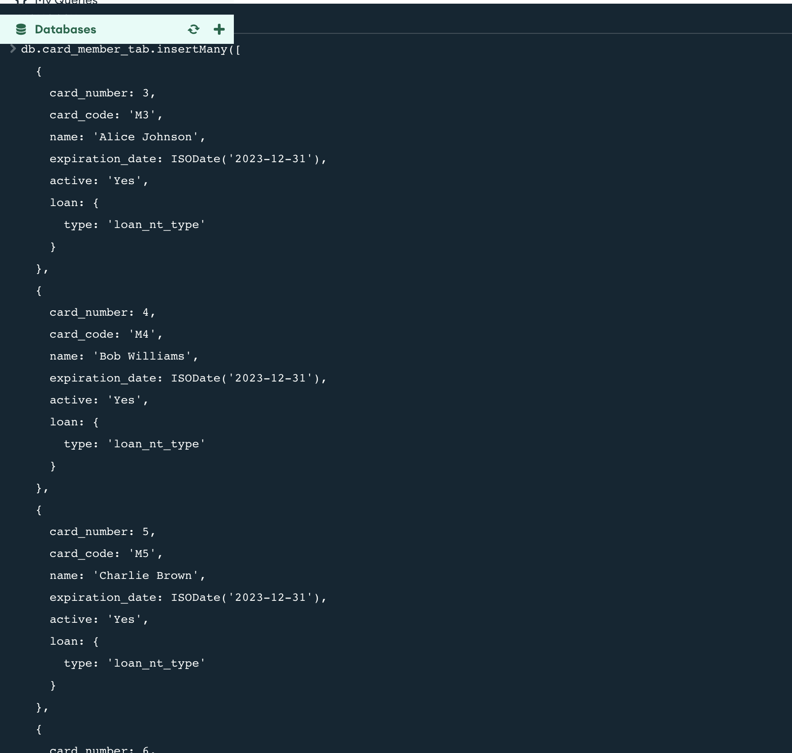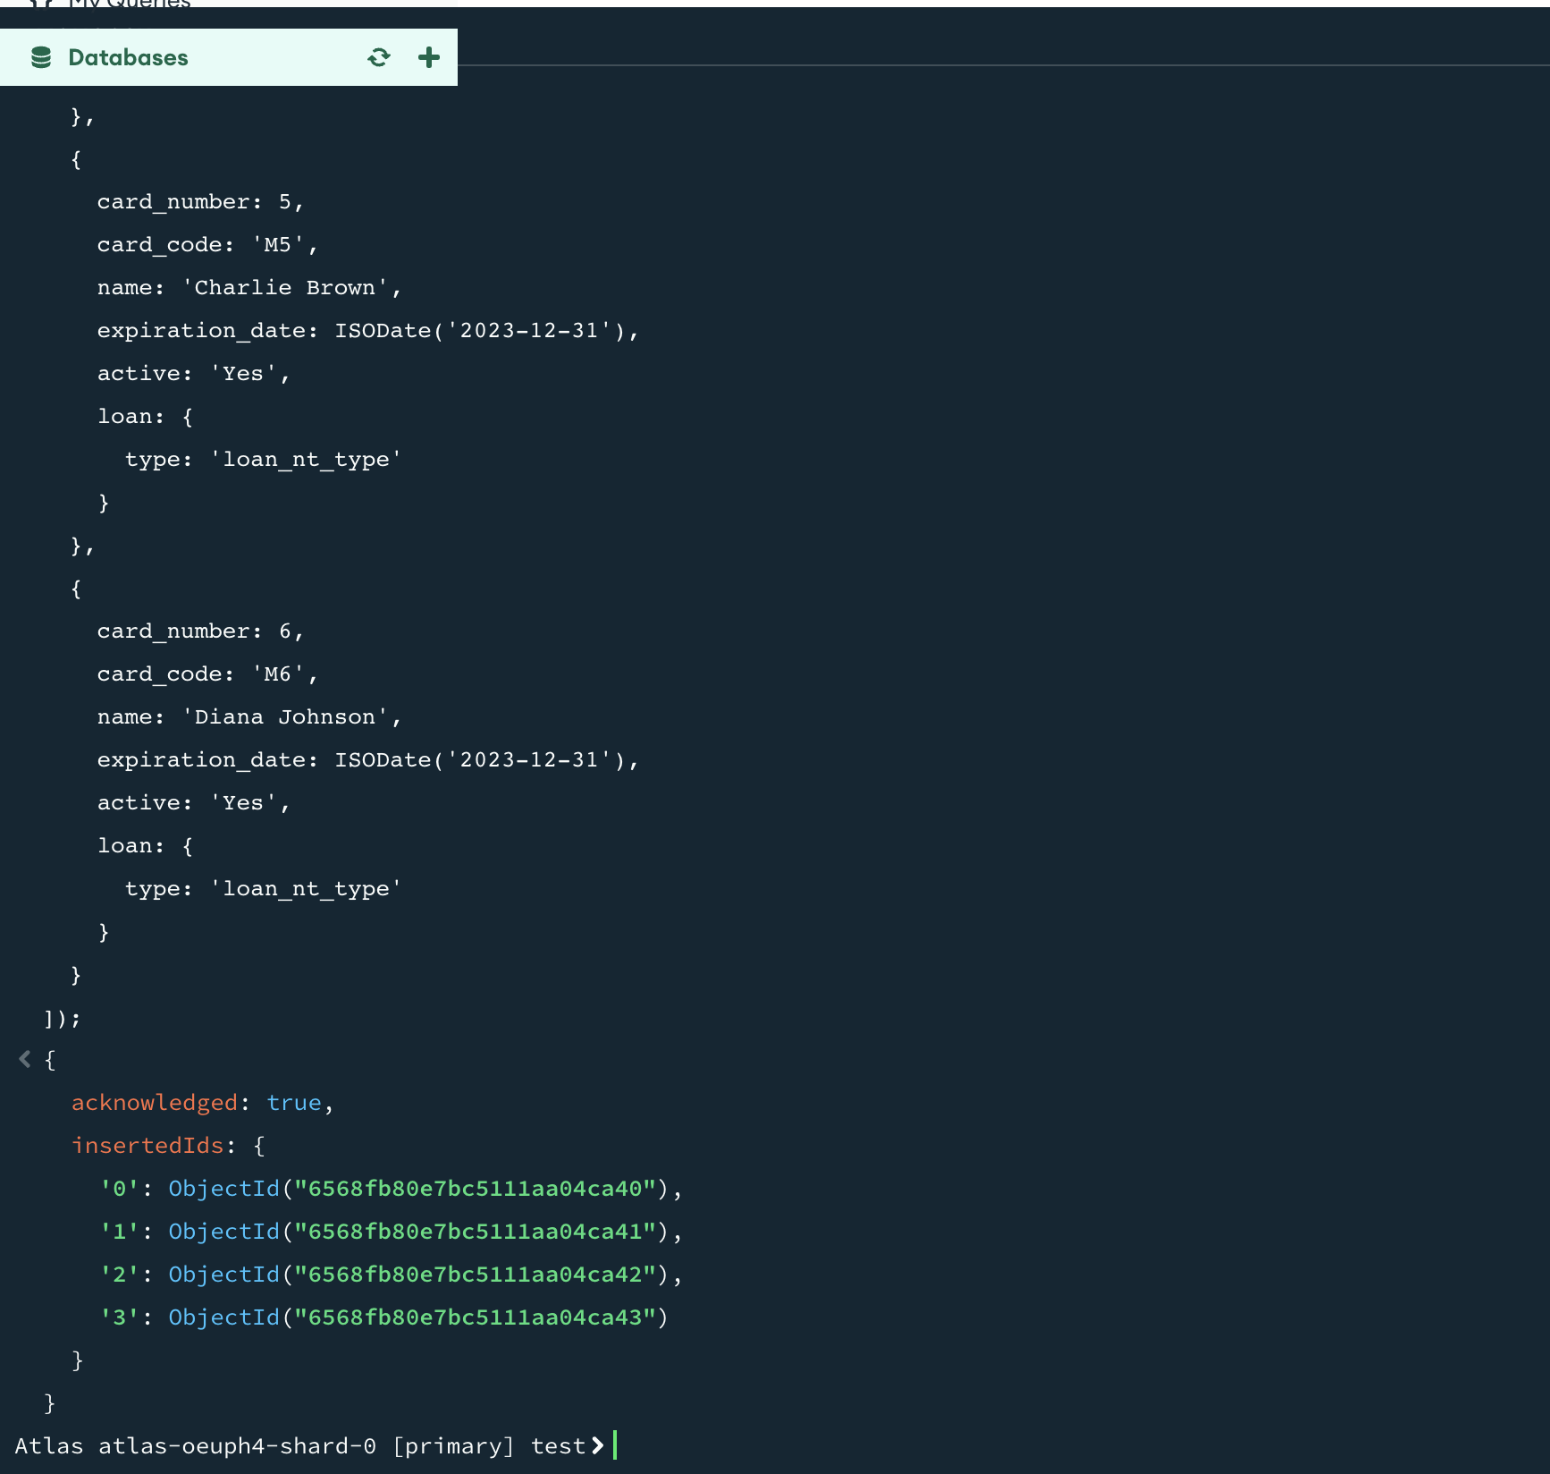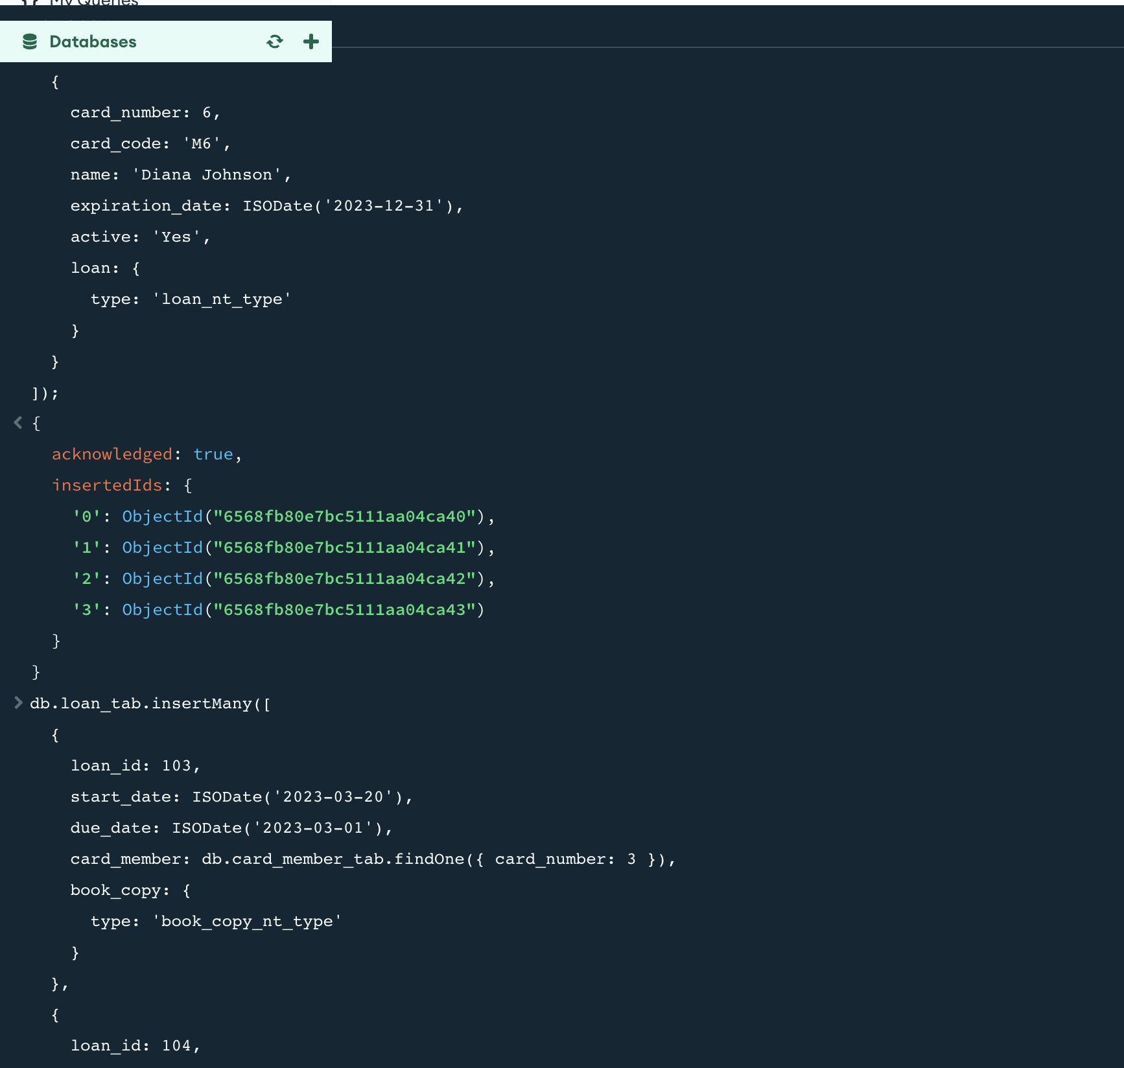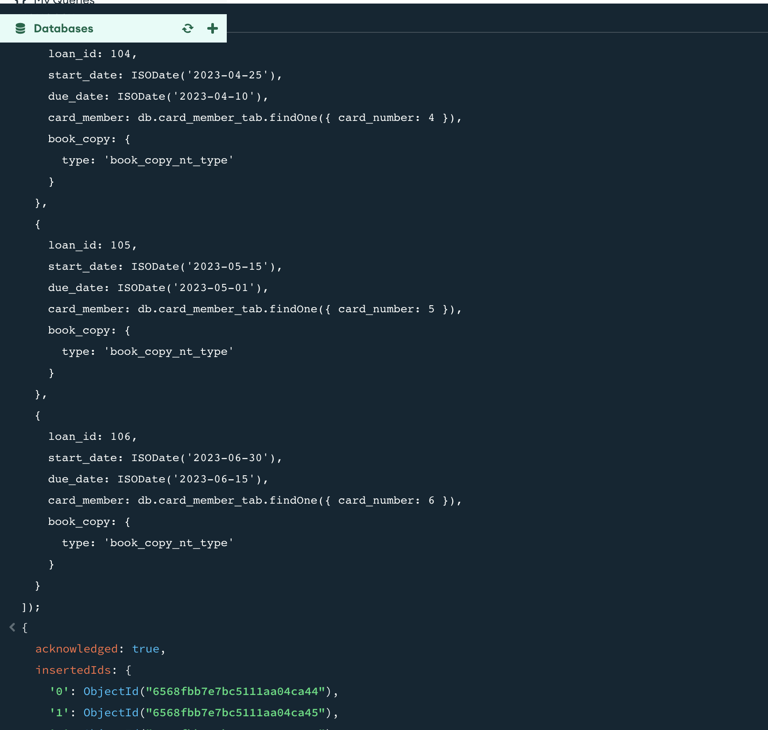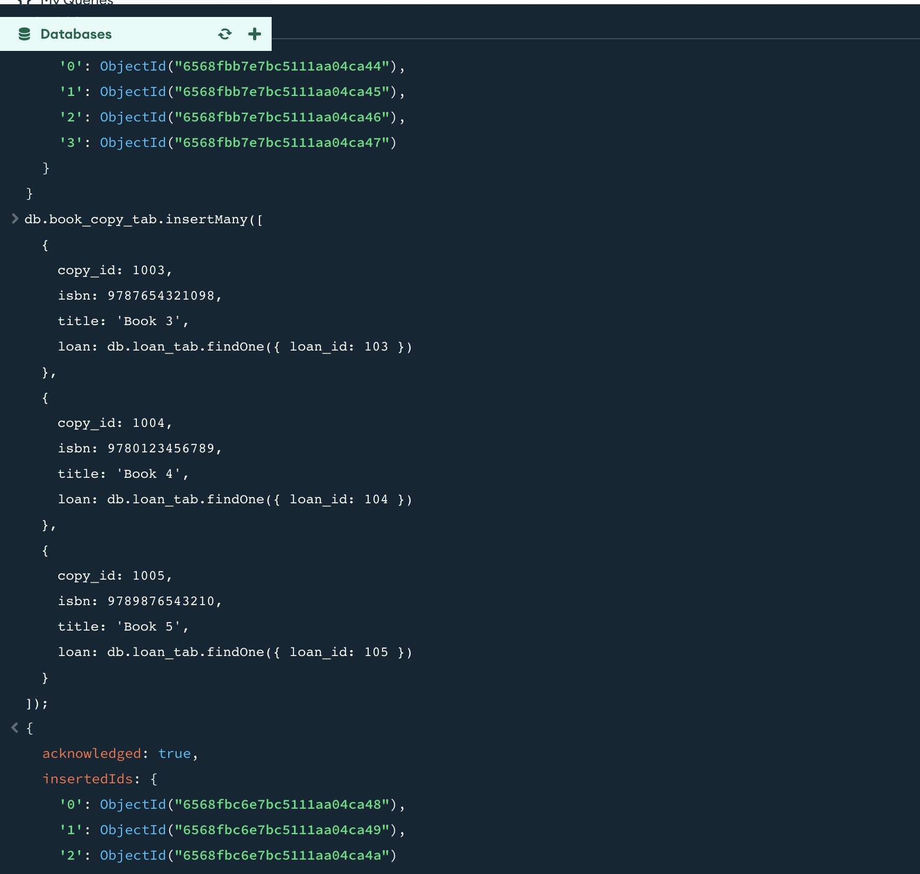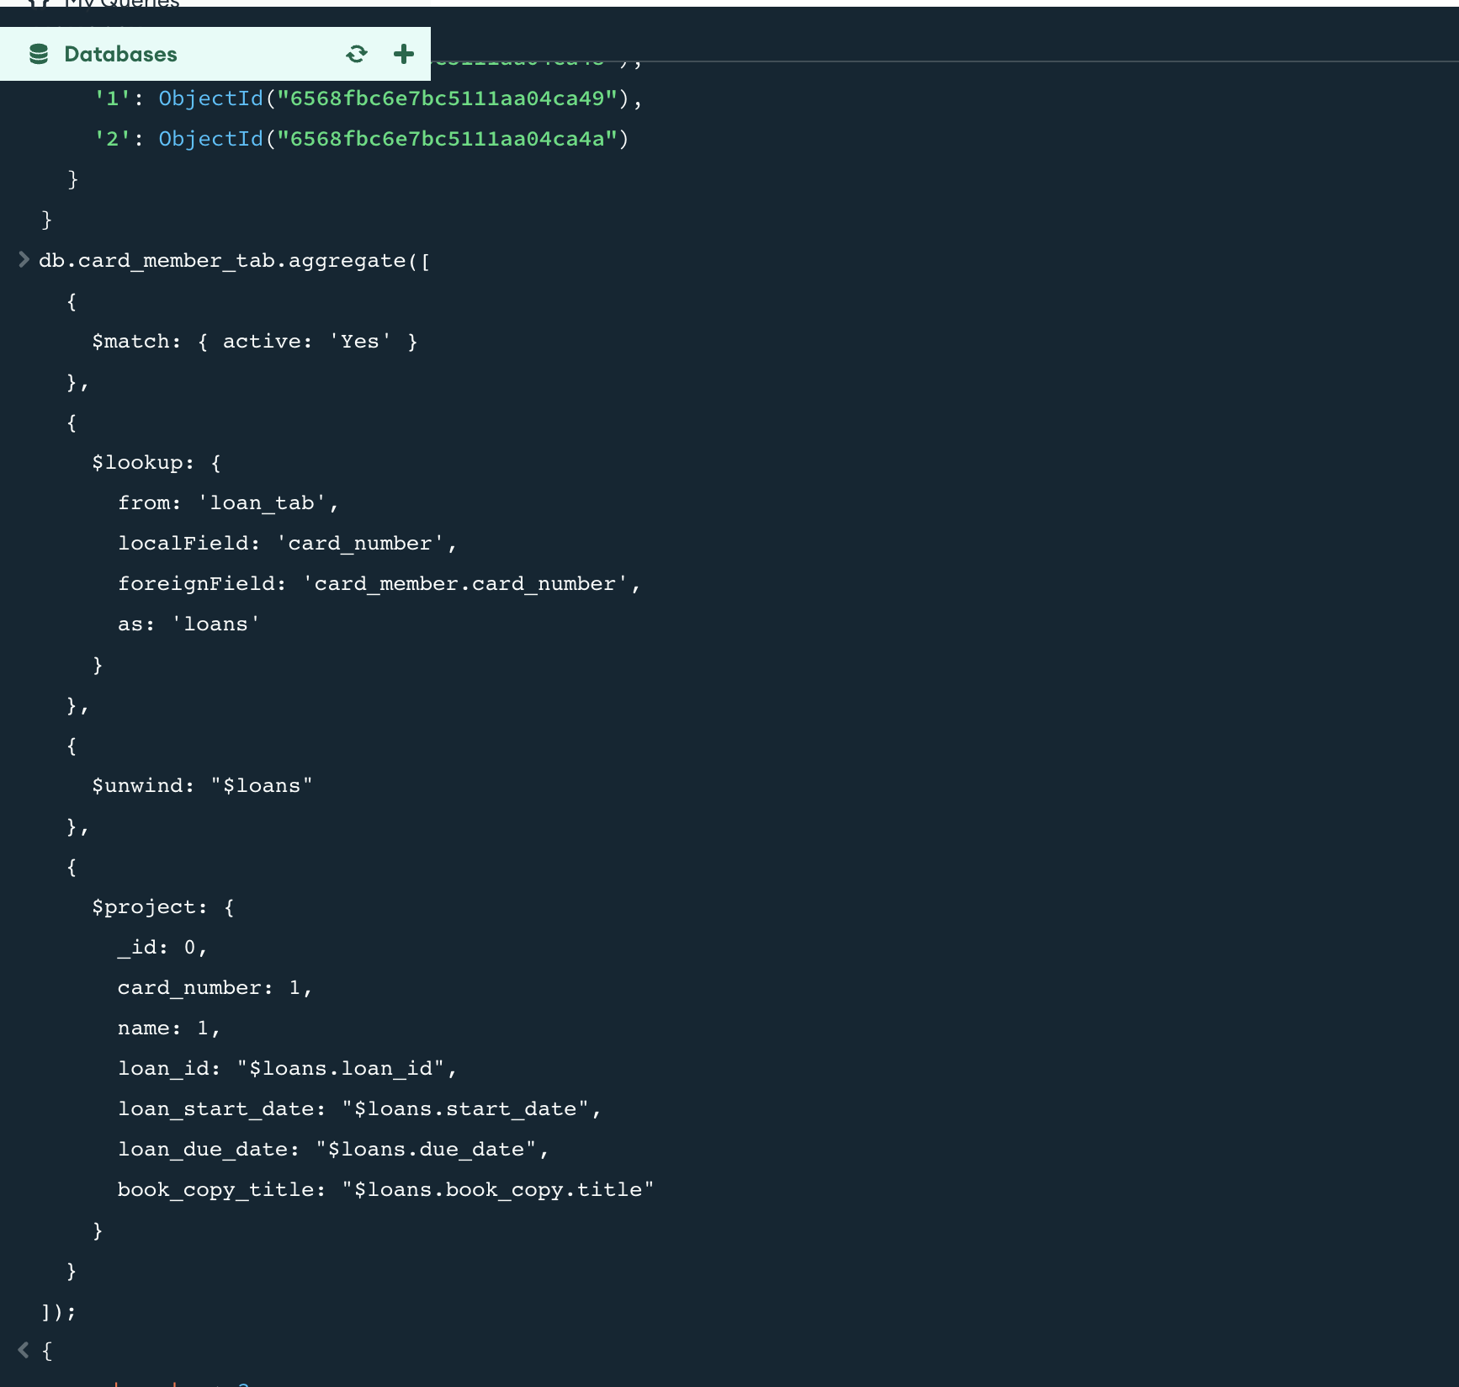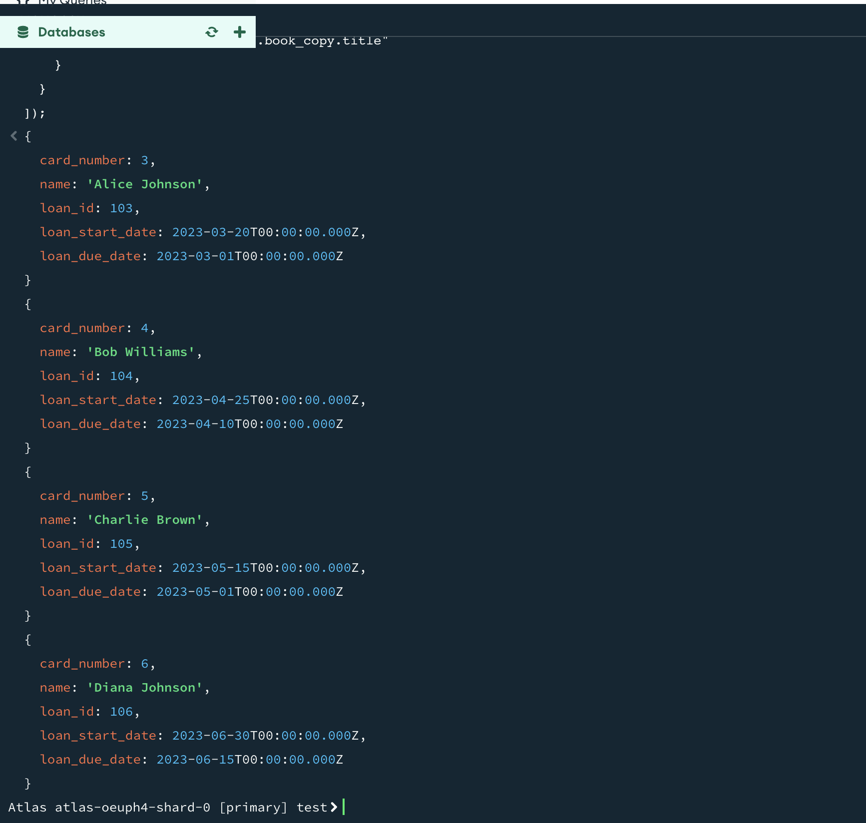

**Part 4 (10 marks)**

*Consider the BLS scenario in the Appendix. Produce a report for the Lord Mayor of BCC – elaborating on sustainability, professional, legal, ethical and security issues, and matters related to diversity, inclusion, cultural, societal and environment as well as risk management and evaluation of commercial risks that need to be considered and make appropriate recommendations for BLS. Whilst answering this question, employ a critical review of current and relevant literature, systems, developments, and standards.*

(10 marks)

The report should be concise and comprehensive and in the region of 900-1000 words. You should use Harvard style of citation and referencing by following the guidelines in Pears and Shields (2008).

**Answer Part 4: 10 Marks** [8 for the quality of report covering all the above issues, 1 for the quality of referencing and citation and adhering to the Harvard style, 1 for presentation]

Comprehensive Analysis of Sustainability, Professionalism, Legal Compliance, Ethics, Security, Diversity, Inclusion, Cultural, Societal, and Environmental Considerations in Library Operations

# Executive Summary:

In the context of library operations, this report goes into great detail about some of the most important things to think about when it comes to sustainability, professionalism, legal compliance, ethics, security, diversity, inclusion, cultural, societal, and environmental effects, as well as risk management in BLS. The report's goal is to make suggestions for how to make the BLSlibrary more successful and resilient as a whole.

## Sustainability:

(Mannaa & Sarkar, 2022) mentions BLS Library like sustainability includes carbon footprint reduction, energy efficiency, and user interaction, according to the report. Libraries seeking carbon-neutral status must prioritise digitization, energy efficiency, and green construction. Technological advances may harm the environment and there are no clear sustainable development criteria. BLS Libraries should develop special rules, invest in carbon emission monitoring, and balance technical advances with environmental concerns to overcome barriers. Space management and community interaction are also crucial. The study shows libraries how to take a holistic approach to a greener, more resilient future.

## Professionalism:

All kinds of people use the BLS like system, from students and faculty to community members and researchers and scholars from every field. Librarians need to commit to ongoing learning in order to provide quality services to that group of people. The phrase "Knowledge is boundless" refers to the endless search for knowledge.

The people in the academic community get together around shared knowledge and scholarship. Professional development programmes are very flexible. They can be formal or informal, big or small, virtual or real. This means that library workers will learn the skills they need to help their clients and themselves get ahead. The most important thing is that those chances for professional growth are made available.

## Legal and Ethical Considerations:

Copyright, privacy, and other legal requirements should be audited regularly. It is important to provide library staff with comprehensive ethics training on patron privacy, intellectual freedom, and information access.

(Mannaa & Sarkar, 2022) found that Nigerian federal university information service providers follow morality and seek justice. However, many seem unaware of these rules, which could hurt their work. According to the study, these professionals need more legal and ethical training to improve their services. It advises the Nigerian Library Association and Librarians' Registration Council to consider these issues when accrediting educational institutions. The study also suggests including these topics in future librarian education and giving current librarians opportunities for personal and professional growth.

## Security:

Protecting patron data and library systems with strong cybersecurity is important. To prevent data breaches and cyberattacks, performing regular security audits, updating security software and training staff on cybersecurity are required.

In the past, libraries likeBLSprioritised confidentiality and privacy over cybersecurity. The study of Estonian librarians found that their information security awareness is good, but device use and incident prevention need improvement. Because librarians are responsible for protecting institutional data and information resources, staff members need to receive cyber threat and risk training. The study suggests that librarians can educate users and the community about cyber security with proper training. The study found that library staff are willing to participate but lack sufficient training. IT concludes that ongoing training is crucial, especially given technological advances. Further research will examine whether seniority, age, or library type affect employees' information security awareness.

## Diversity, Inclusion, Cultural, and Societal Considerations:

(Bledsoe et al., 2022) states Diversifying library collections is an ongoing process. Diversity definitions change as communities and standards do, so there is no final stage. Libraries should diversify their collections without a clear endpoint, but they can set diversity, equity and inclusion goals.Libraries need a plan to integrate collection diversification into their goals. This means clearly explaining how these activities support the library's mission. We must also create a library culture that recognises these commitments as ongoing. New hires should learn about the library's DEI strategy and their role in achieving it. Diversity efforts may be paused due to academic calendars, hiring timelines, or unexpected events like a global pandemic. But library leaders may need to re-energize their staff and refocus on diversity after the break.

## Environmental Impact:

(Gupta, 2020 ) Use energy-efficient technologies, sustainable building practices, and eco-friendly purchasing to reduce library operations' environmental impact. Teaching patrons about environmental issues through workshops and exhibits promotes environmental responsibility.

Librarians are now social responsibility leaders. Being "digital" and "social" librarians is their new role. Libraries are focusing more on sustainability. Librarians are researching green libraries, which use eco-friendly building designs, green technologies, and literacy programs.

International Federation of Library Associations and Institutions (IFLA) Green Library initiative promotes library sustainability worldwide. Libraries should contribute to the green movement and promote environmental stewardship. Libraries want to lead the way in eco-friendly and sustainable practices.

## Risk Management:

Anyone who uses or works in the library should be involved in risk management. Focus on risk prevention through analysis, simulation, preparation, and trainingThe library not only enforces regulations but also influences and builds university and external networks. Risk management should be part of the library's management system and operations. Risk prevention and management require staff education, networks, resource allocation and clear rules and regulations. It stresses involving library users and preparing for major and minor incidents that could affect the library's reputation or functions.

# Conclusion:

By addressing sustainability, professionalism, legal and ethical considerations, security, diversity, inclusion, cultural and societal factors, environmental impact, and risk management, libraries can not only fulfill their traditional roles but also evolve into resilient and dynamic community hubs. Implementing the recommended strategies will contribute to the long-term success and relevance of the library in an ever-changing landscape.

**References**

Bledsoe, K., Cooper, D. M., Schonfeld, R., & Rieger, O. (2022). Leading by Diversifying Collections. *A Guide for Academic Library Leadership*. https://doi.org/10.18665/sr.317833

Gupta, S. (2020). Green Library: A Strategic Approach to Environmental Sustainability. *International Journal of Information Studies & Libraries*. http://publishingindia.com/ijisl/

Mannaa, D., & Sarkar, T. D. (2022). Sustainable development initiatives in libraries: A critical analysis. *Annals of Library and Information Studies*, *69*(4). 10.56402/alis.v69i4.66044

Mbofung, Ucha, mrs, Popoola, & Sunday, D. O. (2014). Legal and Ethical Issues of Information Service Delivery and Library Information Science Professionals in University Libraries in Nigeria. *Library Philosophy and Practice*. http://digitalcommons.unl.edu/libphilprac/1183